Human Behavior, Ethics & Wisdom
Question Bank – Solved Study Material
SY B.Tech • PCCOE Pune • AY 2026-27 • Summative exam (30 marks)

Unit 1 – Understanding Success and Living Domain of Human
Unit 2 – Human Behavior
Unit 3 – Wisdom & Universal Harmony
Unit 4 – Ethics & Human Conduct

How to use this material
Summative exam: 30 marks, 1 hr 15 min, 4 questions (one block per unit), all compulsory, with options inside Q3 and Q4. Questions carry 2, 4 or 5 marks.
Question | Parts | Marks
Q.1 (compulsory) | A: i), ii) B: i), ii) | 5 + 2
Q.2 (compulsory) | A and B | 4 + 4
Q.3 | A: any one of i)/ii) B: compulsory | 5 + 2
Q.4 | Any two of A, B, C | 4 + 4

How long should my answer be?
Marks | Write about | Must include
2 marks | 4–6 lines (≈50–70 words) | Definition + 2 key points or one example
4 marks | ≈ 1 page (≈120–160 words) | Definition, 4–5 points, a diagram or table if it fits
5 marks | 1–1.5 pages (≈160–220 words) | Intro, 5–6 points / steps, labelled diagram, example, short conclusion
6 marks | 1.5 pages (≈220–260 words) | Everything for 5 marks + comparison table or worked example

Exam tips: underline key words, draw neat labelled diagrams (they earn marks even when text is short), use point-wise answers, and end long answers with a one-line conclusion. The green "Remember" boxes give a short trick to recall each answer.

Contents
How to use this material 2
Contents 3
Unit 1: Understanding Success and Living Domain of Human 9
A-Q1. Differentiate between academic success and career success. 9
A-Q2. Differentiate between career success and life success. 9
A-Q3. What is meant by the ultimate goal of the human being? 9
A-Q4. Explain the difference between happiness and excitement. 10
A-Q5. What is temporary pleasure? Give one example. 10
A-Q6. What is continuous happiness? 10
A-Q7. Why is life success broader than academic and career success? 10
A-Q8. Why should Physical Facility not be given first priority? 11
A-Q9. How does Right Understanding affect choices? 11
A-Q10. How do relationships affect choices? 11
A-Q11. How does Physical Facility affect choices? 12
A-Q12. What is meant by understanding the human being on the basis of needs? 12
A-Q13. What is meant by understanding the human being on the basis of activities? 12
A-Q14. Give one example showing difference between excitement and happiness. 12
B-Q1. Explain the difference between happiness, excitement, and temporary pleasure. 13
B-Q2. Explain Right Understanding, Relationship, and Physical Facility with examples. 14
B-Q3. Discuss the correct priority among Right Understanding, Relationship, and Physical Facility. Why is this priority important? 14
B-Q4. Explain how a student can apply Right Understanding, Relationship, and Physical Facility in daily academic life. 15
B-Q5. Explain the human being on the basis of needs and activities. 15
B-Q6. Why is continuous happiness different from temporary pleasure? Explain. 16
B-Q7. Explain why life success should be the guiding frame for academic and career success. 17
B-Q8. "Physical facilities are necessary but not sufficient for human happiness." Explain. 17
B-Q9. Explain the role of self-reflection in understanding success and happiness. 18
B-Q10. Explain with a suitable example how wrong priority among Right Understanding, Relationship, and Physical Facility can create stress. 18
B-Q11. How can the distinction between need and desire help in achieving life success? 19
C-Q1. A student says, "If I get high marks, my life will be successful." Comment on this statement. 19
C-Q2. A student wants to choose a job only because it offers the highest salary. Analyze using Right Understanding, Relationship, and Physical Facility. 20
C-Q3. A student buys a new gadget and feels very happy for two days, but later wants another new gadget. Explain this situation. 21
C-Q4. A student studies only because of fear of failure. How can Right Understanding change this approach? 22
C-Q5. A student has good physical facilities but still feels dissatisfied. Explain using course concepts. 22
C-Q6. A student says, "Entertainment gives me happiness." Explain how you would guide the student. 23
C-Q7. A student ignores family and friends to focus only on career. Evaluate this decision. 23
C-Q8. A student is confused between what is needed and what is desired. Suggest a method using course concepts. 24
Quick Revision – Unit 1 25
Unit 2: Human Behavior 26
Q1. Rohan participates actively in family, college, and social activities but often acts without understanding the purpose. What is meant by purposeful participation in human behavior? Illustrate with an example. 26
Q2. A student feels excited after receiving a new smartphone but becomes normal after a few days. Explain the difference between excitement and continuous happiness using this situation. 26
Q3. Meena strongly desires a promotion and constantly worries that someone else may get it. Explain why fear is called the shadow of desire. 26
Q4. A person worries about losing respect, money, position, and even physical safety. Identify and explain the four fears represented in this situation. 27
Q5. Zahir purchases expensive clothes whenever he sees attractive advertisements, even though he does not need them. Explain sensation-driven behavior with reference to this example. 27
Q6. Two friends have different opinions about each other. One judges the other only by marks, while the other recognizes the person beyond performance. Which reflects right evaluation? Explain. 27
Q7. A student says that justice means only giving punishment to a person who has done something wrong. Using an example, explain the four components of justice. 28
Q8. A family member supports another during difficulties but expects nothing in return. Identify the human values involved and explain their significance among the nine core human values. 28
Q9. Rahul considers marriage mainly as a means of fulfilling physical needs, while his parents explain it as a relationship for mutual fulfillment and family development. Critically examine both views. 28
Q10. A father repeatedly tells his child to speak respectfully but frequently speaks rudely to others. Explain why parenting is demonstration rather than mere instruction. 29
Q11. A student desires to become the class topper and starts comparing himself constantly with others. Analyze how desire influences his behavior. 29
Q12. A faculty member knows the right decision but avoids taking it because of fear of losing popularity. Explain how fear can influence human behavior. 30
Q13. Two students face the same disagreement. One reacts angrily, while the other tries to understand the situation and resolve it peacefully. Which behavior is understanding-based? Justify. 31
Q14. Neha spends the entire evening watching entertainment videos and feels happy temporarily but dissatisfied afterward. Differentiate temporary pleasure and happiness in this case. 31
Q15. A son expects his parents to provide everything but does not recognize their efforts. Identify the missing expectation in the relationship and explain how it can be fulfilled. 31
Q16. A student shares a personal difficulty with a friend because she believes the friend will not misuse the information. Identify the value demonstrated and explain its role in friendship. 32
Q17. A teacher respects every student equally, but students respect only those who score high marks. Analyze the difference between respect and evaluation based on comparison. 33
Q18. An elderly parent becomes ill, and the son rearranges his schedule to support the parent. Which human values are demonstrated? Explain their relationship with responsibility. 34
Q19. Two siblings frequently disagree but continue to support each other during difficult situations. Explain how affection can exist even when differences of opinion are present. 34
Q20. A student helps his classmate understand a difficult topic instead of simply giving the answer. Explain how this action can contribute to justice and mutual happiness. 34
Q21. A couple decides important family matters through mutual understanding rather than domination by one partner. Explain how this reflects the purpose of marriage and right relationship. 35
Q22. In a family, household responsibilities are assigned only according to gender. Analyze the situation from the perspective of dignity and equality. 36
Q23. Parents regularly discuss honesty with their children but themselves provide false information to others. Critically analyze the likely impact of this behavior on the child. 36
Q24. A student wants an expensive motorcycle, fears that friends may consider him unsuccessful, and purchases it mainly for social recognition. Identify the roles of desire, fear, and sensation. 37
Q25. A company promotes an employee only because of his technical performance, ignoring his honesty and responsibility. Critically examine whether this represents complete evaluation of the person. 38
Q26. Two brothers argue about the division of family responsibilities because each believes the other should do more. Explain how recognition, fulfillment, and evaluation can help resolve the conflict. 38
Q27. A teacher patiently guides a weak student, while the student sincerely follows the teacher's guidance. Identify the values operating in this relationship and explain their importance. 39
Q28. During an examination, a student is tempted to cheat because of fear of failure. Explain how understanding-based behavior could help the student respond differently. 40
Q29. A student has good academic performance, a successful career, many material possessions, but remains dissatisfied and fearful about losing his status. Analyze the situation using Right Understanding (RU), Relationship (R), and Physical Facility (PF). 40
Q30. A family has sufficient physical facilities but frequent conflicts among parents, children, and siblings. Members also experience comparison, fear, and dissatisfaction. Using the concepts of human behavior, relationships, justice, values, marriage, and parenting, identify the major issues and suggest an understanding-based approach for creating mutual happiness. 41
Quick Revision – Unit 2 42
Unit 3: Wisdom & Universal Harmony (Holistic Living) 44
Q1. Explain the meaning of Knowledge, Wisdom and Science in the context of human living. 44
Q2. Explain the relationship Knowledge → Wisdom → Science. 44
Q3. Define sustainable living according to Madhyasth Darshan. 44
Q4. Explain the meaning of prosperity in Madhyasth Darshan. 45
Q5. Differentiate between need and greed with one suitable example. 45
Q6. Explain the meaning of holistic living. 45
Q7. List and explain the four dimensions of the human goal. 46
Q8. Explain the meaning of Resolution as a dimension of the human goal. 47
Q9. Explain the meaning of Fearlessness in a harmonious society. 47
Q10. Name the five dimensions of human participation and briefly explain them. 47
Q11. Name and explain the four orders in nature. 48
Q12. Explain the meaning of mutual fulfillment among the four orders. 48
Q13. Explain how right understanding leads to sustainable living. 49
Q14. Explain the difference between wealth/physical facility and the feeling of prosperity. 50
Q15. Explain how uncontrolled competition can affect sustainable living. 50
Q16. Describe the holistic approach to sustainable production using the sequence Need → Resource → Production → Utilization → Reuse/Recycle → Natural Restoration. 50
Q17. Explain why technology is neither inherently sustainable nor unsustainable. 51
Q18. Explain how an individual can practice sustainable living in everyday life with reference to food, water and energy. 52
Q19. Explain the transition from "consumer" to "contributor" in Madhyasth Darshan. 52
Q20. Describe the human role in society through right understanding, right feeling, right behaviour, right work and right participation. 53
Q21. Explain how Resolution, Prosperity, Fearlessness and Coexistence are interconnected. 53
Q22. Explain the role of Education–Sanskar in fulfilling the human goal. 54
Q23. Explain the relationship between Justice–Protection and fearlessness in society. 54
Q24. Explain the relationship between Exchange–Storage and continuity of resources. 55
Q25. Explain how holistic understanding of development differs from development measured only through GDP, industries, consumption and technological advancement. 55
Q26. Explain how Resolution converts understanding into consistent conduct, with a suitable example from engineering practice. 56
Q27. Explain how Prosperity differs from unlimited accumulation and how it contributes to sustainable living. 57
Q28. Explain the relationship Right Understanding + Trust + Justice + Prosperity → Fearlessness. 57
Q29. Explain coexistence as a dimension of the human goal and relate it to sustainable living. 58
Q30. Explain how the five dimensions of human participation are interconnected, using the smart energy management system as an example. 59
Q31. Explain the interconnectedness and mutual fulfillment among the Material, Plant/Bio, Animal and Human orders. 60
Q32. Differentiate between the exploitative approach and the holistic approach toward nature, and explain their consequences. 61
Q33. Explain how a human being can either disturb the natural order or participate in mutual fulfillment. 62
Q34. Explain how Individual → Family → Society → Nature → Existence represents an interconnected framework for holistic decision-making. 63
Q35. Explain the complete relationship among Four Human Goals → Five Dimensions → Four Orders → Mutual Fulfillment → Universal Harmony. 64
Quick Revision – Unit 3 65
Unit 4: Ethics 66
Q1. Explain the meaning of Ethics as Humane Conduct according to holistic understanding. 66
Q2. Explain the need for ethics in the context of scientific and technological advancement. 66
Q3. Describe the relationship between right understanding and ethical conduct. 67
Q4. Explain why rules, regulations and punishment alone are insufficient to ensure ethical conduct. 67
Q5. Explain the meaning of harmony and co-existence at the levels of the individual, family, society, nature and existence. 68
Q6. Explain the concept of Natural Acceptance and describe its characteristics. 69
Q7. Differentiate between Natural Acceptance and temporary liking arising from sensation, habit, fear, greed or social conditioning. 69
Q8. Explain the difference between External Control and Self-exploration in developing ethical conduct. 70
Q9. Describe how self-exploration leads from Natural Acceptance to Understanding, Resolution and Conduct. 70
Q10. Explain the relationship between self-awareness, self-evaluation and Right Understanding. 71
Q11. Explain the meaning of Responsibility and distinguish it from an externally assigned duty. 71
Q12. Describe the relationship between Recognition, Trust, Responsibility, Participation and Mutual Fulfilment. 72
Q13. Explain the meaning of Gender Equality in Dignity and the statement "Difference in Role does not mean Difference in Dignity." 72
Q14. Explain the importance of equal human dignity in family, educational institutions and professional life. 73
Q15. Explain the meaning of Definite Human Conduct and its relationship with Right Understanding. 73
Q16. Explain the three dimensions of ethical living: Values, Character and Work Ethics. 74
Q17. Explain the relationship among Values, Policy and Character. 75
Q18. Describe the role of trust, respect, affection, care, guidance, reverence, gratitude and love in human relationships. 75
Q19. Explain the meaning of Value as Participation in the Larger Order, distinguishing it from monetary price. 76
Q20. Explain the values associated with the Self and human-human relationships according to the presentation. 77
Q21. Explain the three policies of Enrichment, Protection and Right Utilization of the Self, Body and Physical Facility. 77
Q22. Explain the meaning of Right Work and its relationship with mutual enrichment and eco-friendly production. 78
Q23. Describe the sequence Need → Production → Right Acquisition → Utilization → Preservation → Prosperity in the context of Right Wealth. 78
Q24. Explain the meaning of Right Marital Relationship in terms of recognition, trust, respect, responsibility and mutual fulfilment. 79
Q25. Explain the concepts of Righteous Wealth, Loyalty in Marital Relationship, Compassionate Work and Behavior in the context of ethical living. 80
Q26. Explain the significance of Non-accumulation, Affection, Simplicity, Right Knowledge, and Fearlessness in human relationships and social order. 80
Q27. Explain the principles of natural cyclicality, complementarity in balance and expenditure in proportion in relation to nature. 81
Q28. Explain how harmony at the individual and family levels contributes to justice, fearlessness and Universal Human Order. 82
Q29. Explain the difference between technical competence, expressed through "Can I do it?", and professional ethics, expressed through "Should I do it?". 82
Q30. Explain the responsibilities of an engineer toward the Self, Users, Organization, Society and Nature. 83
Q31. Describe the characteristics of people-friendly and eco-friendly technology. 84
Q32. Explain the technical and ethical considerations involved in designing a smart energy meter. 85
Q33. Explain how relationship, cooperation, justice and shared responsibility contribute to humanistic management. 85
Q34. Explain how professional ethics connects technical competence with human welfare, mutual fulfilment and harmony with nature. 86
Quick Revision – Unit 4 86

Unit 1: Understanding Success and Living Domain of Human

Section A: Easy Questions

A-Q1. Differentiate between academic success and career success.
Easy
Point | Academic success | Career success
Meaning | Doing well in studies | Doing well in a job or profession
Measured by | Marks, grades, rank, degree | Position, salary, promotion, recognition
Time span | Limited to student life | Spread over working life
Focus | Gaining knowledge and skills | Using skills to earn and contribute
Example | Scoring 9.5 CGPA | Becoming a project manager

Both are useful but partial; they deal mainly with skills and physical facility, not with happiness in living.
Remember: Academic = marks; Career = position. Neither alone = life.

A-Q2. Differentiate between career success and life success.
Easy
Point | Career success | Life success
Meaning | Achievement in profession | Living with happiness and harmony at all levels
Measured by | Salary, post, recognition | Contentment, good relationships, prosperity
Covers | Work life only | Self, family, society and nature
Based on | Skills and competence | Right Understanding + skills
Nature | Can be temporary (can be lost) | Continuous, stable

Conclusion: career success is one part of life success; life success gives it the right direction.
Remember: Career is a part; life is the whole.

A-Q3. What is meant by the ultimate goal of the human being?
Easy
The ultimate goal of every human being is continuous happiness and prosperity, for oneself and for others.
1. Happiness = being in a state of harmony (what is naturally acceptable to me).
2. Prosperity = feeling of having or making more than the required physical facility.
3. It is fulfilled by the right priority: Right Understanding → Relationship → Physical Facility.
4. At the larger level, the human goal is Resolution (individual), Prosperity (family), Fearlessness (society) and Co-existence (nature).
Remember: Goal = Sukh + Samriddhi, continuously, for all.

A-Q4. Explain the difference between happiness and excitement.
Easy
Happiness is the state of being in harmony within oneself and with others. Excitement is a sudden, short stimulation caused by something outside.
Happiness | Excitement
Comes from harmony and right understanding | Comes from outside events or sensations
Continuous, stable | Momentary, rises and falls
No craving afterwards | Leaves craving for more
Example: peace after helping a friend | Thrill of a roller-coaster ride

Remember: Happiness is a flat line; excitement is a spike.

A-Q5. What is temporary pleasure? Give one example.
Easy
Temporary pleasure is a pleasant feeling that comes from sensory interaction with physical things (taste, sight, sound, touch, smell). It depends on physical facility and lasts only for a short time.
- It decreases with repetition (the tenth sweet does not taste like the first).
- It needs more and more to get the same feeling.
- It cannot give continuous happiness.
Example: Eating a favourite pizza feels great while eating, but the pleasure ends soon and the body may even feel uneasy if we eat too much.
Remember: Pleasure lives in the senses, so it ends when the sensation ends.

A-Q6. What is continuous happiness?
Easy
Continuous happiness is the state of being in harmony at every moment, within the Self ('I') and in relationships, not dependent on outside conditions.
1. It is the basic aspiration of every human being.
2. It comes from Right Understanding in the Self and right feelings in relationships (trust, respect, affection).
3. It does not need any sensation or object to keep it going.
4. It does not decrease with time or repetition.
Example: A person who lives in mutual trust with family feels at ease all day, whatever the outside situation.
Remember: Continuous happiness = harmony inside + harmony around.

A-Q7. Why is life success broader than academic and career success?
Easy
Life success means living with happiness and prosperity in harmony at all levels - individual, family, society and nature.
1. Academic success covers only student life (marks, degree).
2. Career success covers only work life (post, salary).
3. Life success includes both, plus relationships, health, values and contentment.
4. A person can have high marks and a big job but still feel stressed and lonely; that is not life success.
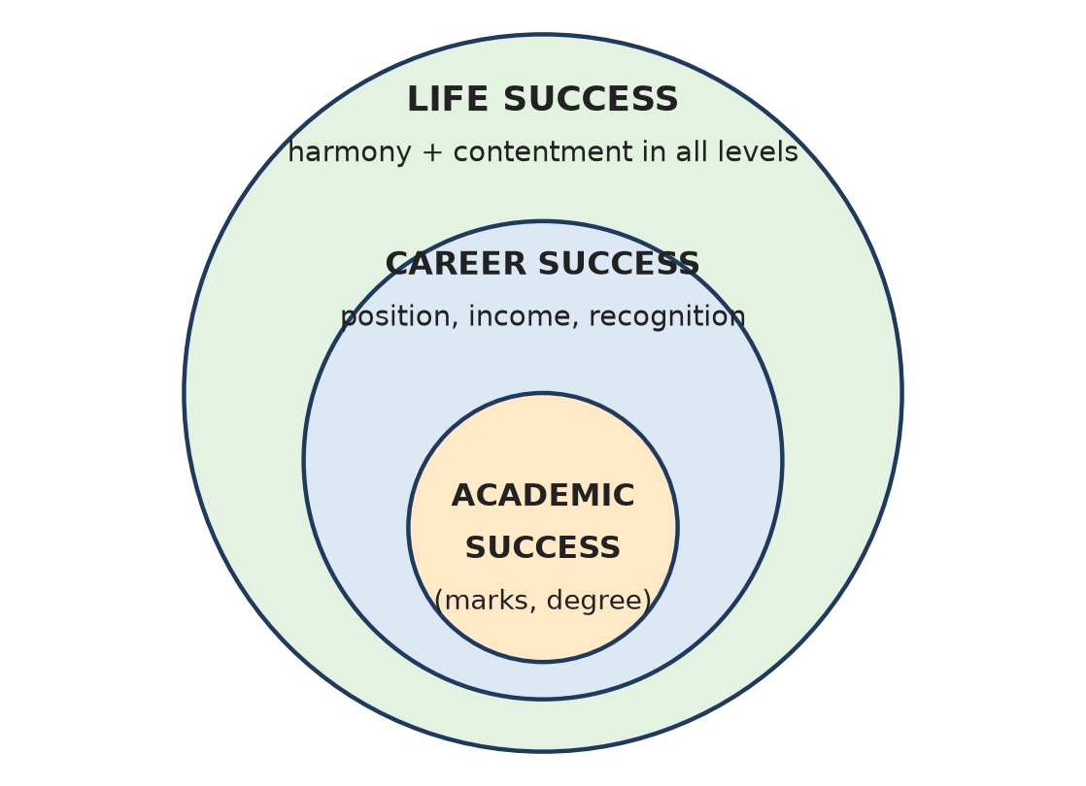
Figure: Three types of success (nested)
Remember: Academic ⊂ Career ⊂ Life.

A-Q8. Why should Physical Facility not be given first priority?
Easy
Physical Facility (PF) fulfils only the needs of the Body, which are limited and temporary.
1. Happiness is a need of the Self ('I'); PF cannot fulfil it.
2. Without Right Understanding, we cannot decide how much PF is needed, so wants become endless.
3. PF-first leads to SSDD - Sampanna but Dukhi-Daridra (rich yet unhappy and feeling deprived).
4. PF-first breaks relationships through comparison and competition.
The right order is Right Understanding → Relationship → Physical Facility.
Remember: PF is necessary but comes third.

A-Q9. How does Right Understanding affect choices?
Easy
Right Understanding (RU) is understanding the harmony in oneself, in family, society and nature.
1. It helps me tell need from desire and choose the right quantity.
2. I choose what is naturally acceptable (mutual happiness), not what is driven by sensation or peer pressure.
3. Choices become consistent, not changing with mood or fear.
4. It leads to choices that fulfil all levels - self, family, society.
Example: With RU, a student picks a branch based on interest and contribution, not only because "everyone is taking it".
Remember: RU is the compass for every choice.

A-Q10. How do relationships affect choices?
Easy
Relationship is the connection between one human and another, fulfilled by feelings (trust, respect, affection, care…).
1. When we feel related, we choose things that bring mutual happiness, not only personal benefit.
2. Good relationships give trust and support, so choices are made without fear.
3. Poor relationships lead to choices driven by comparison, jealousy or ego.
4. We consider the effect of our choice on parents, friends and society.
Example: A student who values family chooses to spend weekends with parents instead of only gaming.
Remember: Relationship makes "my choice" into "our good".

A-Q11. How does Physical Facility affect choices?
Easy
Physical Facility (PF) is the material things needed for the Body - food, clothes, house, gadgets.
1. When PF is the only focus, choices are based on money, brand and show.
2. It can create endless wants, comparison and borrowing beyond means.
3. Lack of basic PF can force choices out of compulsion (SVDD - deprived and unhappy).
4. With RU, PF is chosen in the right quantity, giving prosperity.
Example: Choosing a job only for salary (PF) may ignore health and family.
Remember: PF should serve the choice, not decide it.

A-Q12. What is meant by understanding the human being on the basis of needs?
Easy
A human being is the co-existence of the Self ('I') and the Body, and each has different needs.
Basis | Needs of Self ('I') | Needs of Body
Need | Happiness (sukh) | Physical facility (suvidha)
In time | Continuous | Temporary
In quantity | Qualitative (no measure) | Quantitative (limited)
Fulfilled by | Right understanding and right feelings | Physical facility (food, clothes, shelter)

Mixing up these needs - trying to get happiness from things - is the root of most problems.
Remember: I need happiness; Body needs facility.

A-Q13. What is meant by understanding the human being on the basis of activities?
Easy
Activities of a human being can be grouped by who does them.
1. Activities of the Self ('I'): desiring, thinking, expecting - also called imaging, analysing-comparing, selecting-tasting; and understanding, realising. These go on continuously.
2. Activities of the Body: breathing, heartbeat, digestion - physico-chemical, happen on their own.
3. Activities involving both: eating, walking, talking, seeing - the Self decides and the Body acts as an instrument.
The Self is the seer, doer and enjoyer (drashta, karta, bhokta).
Remember: I decides, Body executes.

A-Q14. Give one example showing difference between excitement and happiness.
Easy
Example: Riya's team wins an inter-college cricket match. She jumps and shouts in joy - this is excitement; by night it fades and she wants another win to feel it again.
Next day, Riya helps a junior understand a topic. Both feel good and the warm feeling of being related stays with her - this is happiness, because it comes from harmony in relationship.
- Excitement: outside event, short, needs repetition.
- Happiness: harmony, continuous, no craving.
Remember: Winning thrills; helping fulfils.

Section B: Moderate Questions

B-Q1. Explain the difference between happiness, excitement, and temporary pleasure.
Moderate
All three feel "good", but they come from different sources and last for different times.
1. Happiness - the state of harmony within the Self and with others; based on Right Understanding and relationship. It is continuous.
2. Excitement - a sudden stimulation caused by an outside event (a win, a surprise, praise). It rises fast and falls back.
3. Temporary pleasure - a pleasant sensation from physical things through the senses (taste, sight, sound). It reduces with repetition.
Point | Happiness | Excitement | Temporary pleasure
Source | Harmony in Self and relationships | Outside event | Sensory contact with objects
Duration | Continuous | Momentary | Short-lived
Dependence | Independent of things | Depends on situation | Depends on physical facility
After-effect | Peace, satisfaction | Craving for more | Boredom or need for more
Example | Trust in family | Team win | Eating ice-cream

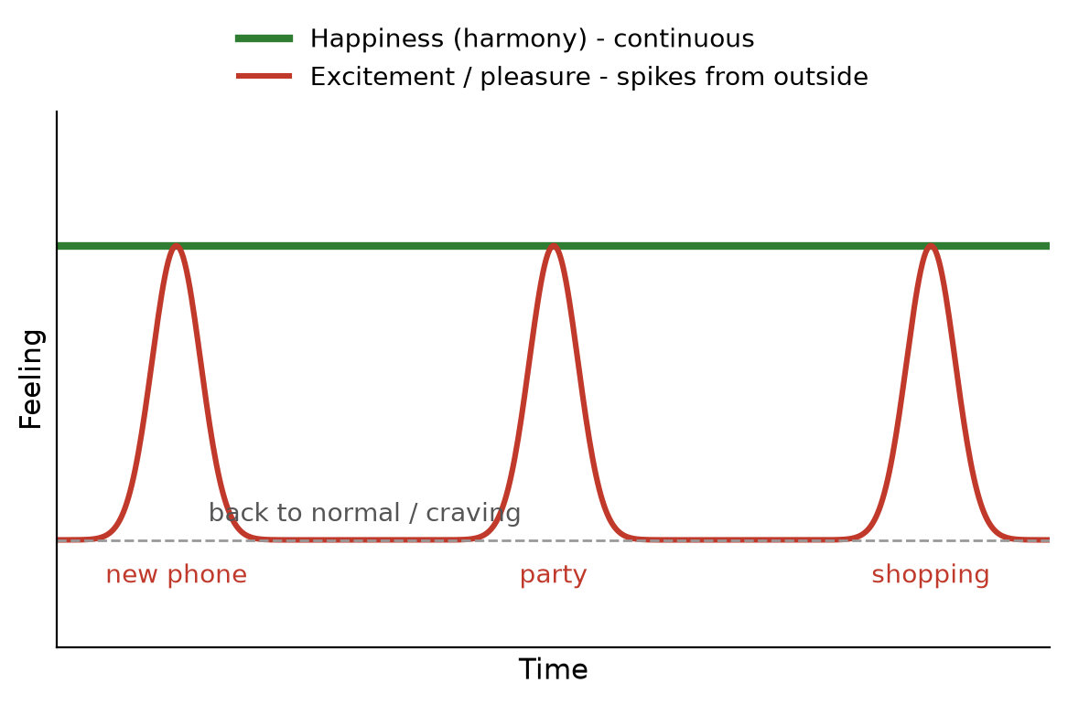
Figure: Happiness vs excitement over time
Remember: Harmony stays, thrill spikes, taste fades.

B-Q2. Explain Right Understanding, Relationship, and Physical Facility with examples.
Moderate
These are the three basic requirements for fulfilling human aspirations (continuous happiness and prosperity).
1. Right Understanding (RU) - knowing the harmony in the Self, family, society and nature; it is a need of the Self ('I').
- Example: understanding that happiness comes from harmony, not from a new phone.
2. Relationship (R) - the connection between humans, fulfilled by feelings like trust, respect, affection, care.
- Example: trust between a teacher and a student; mutual respect among friends.
3. Physical Facility (PF) - material things needed for the Body: food, clothing, shelter, tools.
- Example: a laptop, nutritious food, a hostel room.
How they connect: RU helps us live relationships rightly and decide how much PF is needed. With all three, a person becomes sampanna-sukhi-samriddha (has facility, is happy and prosperous).
Requirement | Need of | Gives
RU | Self ('I') | Clarity, resolution
Relationship | Self ('I') | Mutual happiness
PF | Body | Comfort, prosperity

Remember: RU = clarity, R = feeling, PF = facility.

B-Q3. Discuss the correct priority among Right Understanding, Relationship, and Physical Facility. Why is this priority important?
Moderate
The correct priority is: 1. Right Understanding → 2. Relationship → 3. Physical Facility.
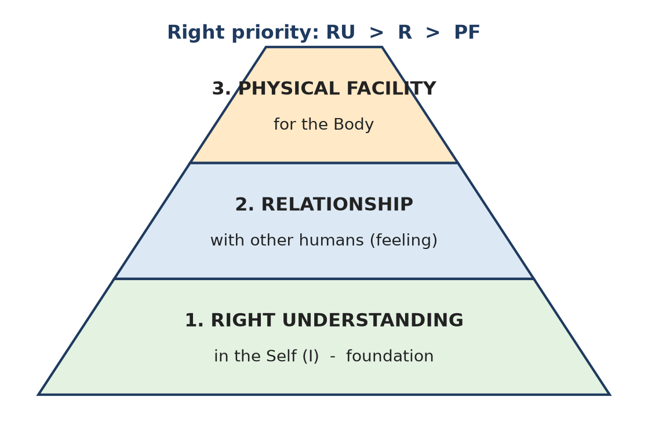
Figure: Priority of RU, R and PF
Why RU first: RU is the base. Without it we cannot fulfil relationships or decide how much PF is enough.
Why Relationship second: Feelings of trust and respect give mutual happiness and make family and society work.
Why PF third: PF is necessary for the Body, but it cannot give happiness. With RU, its required quantity is known, so we can produce more than needed and feel prosperous.
Importance of the priority:
1. Avoids SVDD (no facility, unhappy) and SSDD (facility but unhappy); leads to SSSS (facility, happy, prosperous).
2. Ends endless accumulation and comparison.
3. Keeps relationships free from exploitation.
4. Makes development sustainable with nature.
Animal consciousness looks only at PF; human consciousness includes RU + R + PF.
Remember: First understand, then relate, then acquire.

B-Q4. Explain how a student can apply Right Understanding, Relationship, and Physical Facility in daily academic life.
Moderate
A student can use the three requirements every day in this order:
1. Right Understanding
- Study to understand and contribute, not only to beat others.
- Know the difference between need and desire (a good book vs a costly gadget for show).
- Self-reflect daily: "Did I act with clarity or from fear/peer pressure?"
2. Relationship
- Respect teachers and peers; help classmates in group study.
- Keep trust - no copying, keep promises in team projects.
- Stay connected with family; share problems.
3. Physical Facility
- Use books, laptop, internet for learning, not only entertainment.
- Keep the body fit with proper food, sleep and exercise (sanyam).
- Avoid wasting money on things bought only for status.
Result: less stress, better learning, good friendships, and real progress towards life success.
Remember: Learn rightly, relate kindly, use wisely.

B-Q5. Explain the human being on the basis of needs and activities.
Moderate
A human being is the co-existence of the Self ('I') and the Body. 'I' is the conscious entity (seer, doer, enjoyer); the Body is a material instrument.
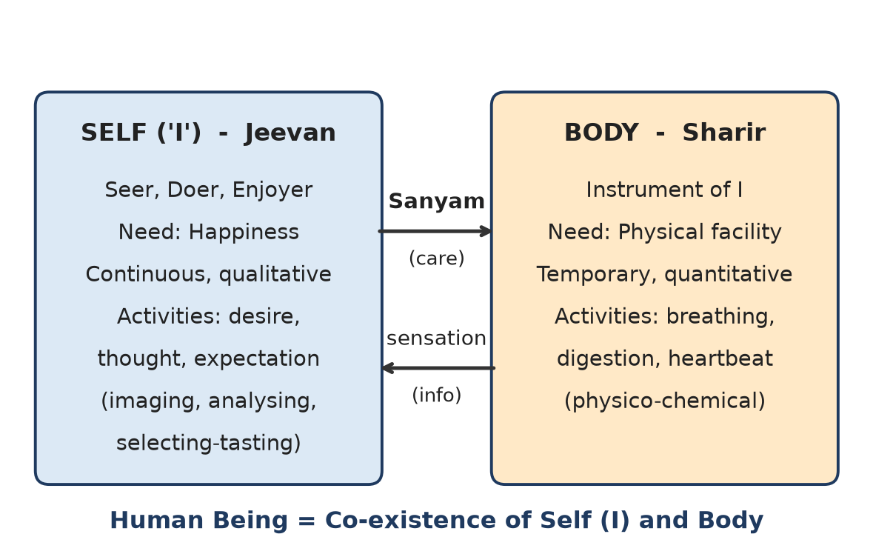
Figure: Human being = Self + Body
On the basis of needs:
Basis | Self ('I') | Body
Need | Happiness | Physical facility
Time | Continuous | Temporary
Quantity | Qualitative | Quantitative
Fulfilled by | Right understanding, right feelings | Food, clothes, shelter

On the basis of activities:
1. Self alone - desires, thoughts, expectations (imaging, analysing, selecting-tasting); continuous.
2. Body alone - breathing, heartbeat, digestion; physico-chemical.
3. Both together - eating, walking, seeing, speaking.
Relation: 'I' gives sanyam (responsibility for nurturing, protecting and rightly using the Body); the Body sends sensations to 'I'. When there is harmony, there is swasthya (health).
Remember: I = consciousness, Body = instrument; harmony between them = sanyam + swasthya.

B-Q6. Why is continuous happiness different from temporary pleasure? Explain.
Moderate
Continuous happiness is the state of harmony in the Self and relationships. Temporary pleasure is a pleasant sensation from physical things.
1. Source: happiness comes from Right Understanding and feelings (need of 'I'); pleasure comes from sensory contact (Body via senses).
2. Duration: happiness lasts; pleasure ends when the sensation ends.
3. Repetition: happiness does not reduce; pleasure reduces with repetition (first gulab jamun vs fifth).
4. Quantity: happiness is qualitative; pleasure depends on quantity of PF.
5. Effect: happiness gives peace; pleasure often leaves craving, boredom or guilt.
6. Mistake we make: we try to get continuous happiness through continuous sensation - this is impossible because the Body's needs are temporary.
Continuous happiness | Temporary pleasure
Need of Self | Felt through Body
Harmony-based | Sensation-based
Stable | Fades

Example: Friendship based on trust keeps giving happiness for years; a movie gives pleasure for three hours.
Remember: Sensation can't be stretched into continuity.

B-Q7. Explain why life success should be the guiding frame for academic and career success.
Moderate
Life success = living with continuous happiness and prosperity in harmony at all levels. It should guide academic and career success because:
1. Gives purpose - studies and job become means to live well and contribute, not ends in themselves.
2. Right priority - RU and relationships come first, so marks and salary do not destroy health or family.
3. Reduces stress - fear of failure and comparison reduce when success is not measured only by marks.
4. Ethical career - a person guided by life goals will not cheat or exploit to climb the ladder.
5. Balance - time for family, health, society and self-reflection.
6. Sustainability - choices that also care for society and nature.
Figure: Life success contains career and academic success
Example: An engineer who chooses a job with fair pay and time for family, and works honestly, is successful in career and life.
Remember: Let life steer; marks and salary are the wheels.

B-Q8. "Physical facilities are necessary but not sufficient for human happiness." Explain.
Moderate
Necessary: The Body needs food, clothing, shelter and tools to survive and work. Without them a person is deprived (SVDD) and cannot focus on anything else.
Not sufficient:
1. Happiness is a need of the Self ('I'), while PF fulfils only the Body.
2. PF gives only temporary pleasure, which fades with time and repetition.
3. Without RU, the need for PF is never-ending - "more" is never enough, so we feel deprived even when rich (SSDD).
4. PF cannot give trust, respect or affection - relationships need feelings.
5. Too much focus on PF causes competition, exploitation and harm to nature.
PF can give | PF cannot give
Comfort for Body | Peace of mind
Convenience | Trust and respect
Physical security | Continuous happiness

Conclusion: PF is required in the right quantity, decided by Right Understanding; then it gives prosperity, not just possession.
Remember: PF fills the stomach, not the Self.

B-Q9. Explain the role of self-reflection in understanding success and happiness.
Moderate
Self-reflection (self-exploration) is the process of looking within and checking our beliefs against our natural acceptance and experience.
1. Find what I really want - continuous happiness, not just marks or money.
2. Check assumptions - "Is success only high salary?" Verify on natural acceptance.
3. See the source of feelings - is my joy from harmony or from excitement/sensation?
4. Separate need from desire - avoid endless wants.
5. Notice disharmony - anger, fear, comparison point to wrong understanding.
6. Correct priority - move from PF-first to RU → R → PF.
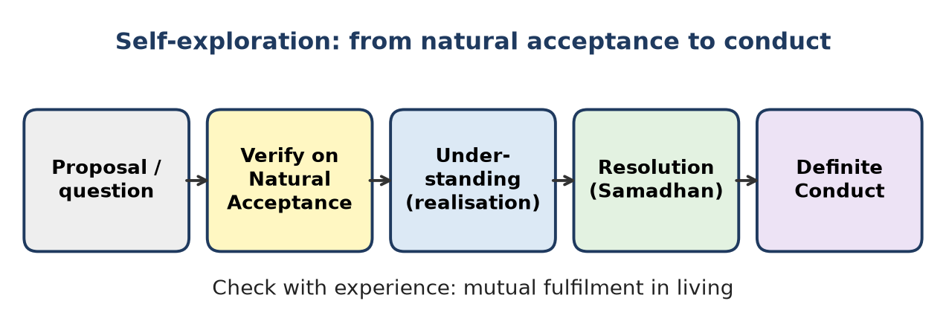
Figure: Self-exploration process
Example: A student feels low after a friend gets a better job. On reflection she sees the pain comes from comparison, not from any real lack, and shifts focus to her own growth.
Remember: Look within before you look ahead.

B-Q10. Explain with a suitable example how wrong priority among Right Understanding, Relationship, and Physical Facility can create stress.
Moderate
Wrong priority means putting PF first and ignoring RU and relationships.
Example: Aman, an engineering student, believes "a costly bike and branded clothes will make me respected". He takes a part-time job, borrows money and skips classes.
How stress builds:
1. No RU - he cannot decide how much is enough, so wants keep growing.
2. Comparison - a friend buys a better bike; Aman feels small again.
3. Relationships suffer - fights with parents about money; less time with friends.
4. Fear - of debt, of failing exams, of losing image.
5. Health - poor sleep, anxiety.
Right priority solution:
- RU: understand that respect comes from right evaluation of a person, not from things.
- R: rebuild trust with parents; spend time with real friends.
- PF: buy only what is needed and affordable.
Wrong (PF first) | Right (RU first)
Endless wants, debt | Need identified, prosperity
Comparison, fear | Trust, contentment

Remember: Wrong order = stress; right order = peace.

B-Q11. How can the distinction between need and desire help in achieving life success?
Moderate
Need is what is truly required for the Self or the Body (food, health, understanding, relationship). Desire (want) is what we feel like having due to sensation, advertisements or comparison.
Need | Desire
Limited, definite | Unlimited
Based on right understanding | Based on sensation / pre-conditioning
Fulfilment gives satisfaction | Fulfilment creates more wants
Example: one good laptop for study | Latest phone every year

How it helps life success:
1. Prosperity - when needs are known, we can produce or earn more than needed and feel prosperous.
2. Less stress - no endless chasing or comparison.
3. Better relationships - money and time are left for family and others.
4. Right priority - RU decides needs; PF is kept in place.
5. Sustainability - less waste, less harm to nature.
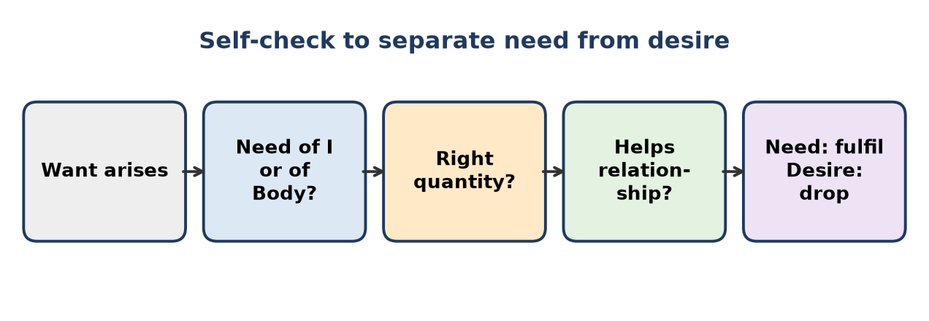
Figure: Self-check to separate need from desire
Remember: Needs can be met; desires can only be managed.

Section C: Application-Based Descriptive Questions – Difficult Questions

C-Q1. A student says, "If I get high marks, my life will be successful." Comment on this statement.
Difficult
Situation: The student equates academic success with life success.
Concept: Three types of success - academic, career, life; human goal = continuous happiness and prosperity.
Analysis:
1. High marks are academic success - useful for admission and jobs, but limited to student life.
2. Life success means harmony in self, family, society and nature; marks do not guarantee this.
3. Many toppers face stress, loneliness or ethical problems later - marks do not give Right Understanding or relationships.
4. Marks bring PF (via job) but PF is necessary, not sufficient.
5. Chasing only marks breeds fear of failure and comparison, which harm happiness now.
Belief of student | Right understanding
Marks = success | Marks = one part of success
Life starts after results | Life is happening now
Others are competitors | Others are co-learners

Right approach:
- Study for understanding and competence, not only marks.
- Keep relationships with family and friends healthy.
- Take care of health (sanyam).
- Reflect: "Am I happy and helping others be happy?"
Conclusion: The statement is partly true - marks support career, but life success needs RU → R → PF in the right priority.
Remember: Marks open doors; understanding builds the home.

C-Q2. A student wants to choose a job only because it offers the highest salary. Analyze using Right Understanding, Relationship, and Physical Facility.
Difficult
Situation: Choice of job is based only on Physical Facility (salary).
Analysis using RU, R, PF:
1. PF view - high salary gives more money and comfort. This is useful but fulfils only the Body's needs.
2. RU missing - the student has not asked: Do I like this work? Does it use my strengths? Is it ethical? How much money do I really need?
3. Relationship ignored - long hours, transfers or high pressure may leave no time for parents, spouse or friends; workplace culture may be based on competition, not trust.
4. Result - possible SSDD: well paid but unhappy, stressed and feeling "not enough".
Factor | Salary-only choice | Holistic choice
RU | Not considered | Interest, values, purpose checked
R | Neglected | Time for family, good team
PF | Maximum | Sufficient, with prosperity
Outcome | Stress, comparison | Satisfaction, growth

Suggested approach:
- List needs (family support, savings) and see what salary is sufficient.
- Check nature of work, learning, work-life balance, ethics of the company.
- Choose a job that gives fair pay and happiness in work and relationships.
Conclusion: Salary is a valid factor but must come third, after understanding and relationship.
Remember: Pay matters; purpose and people matter more.

C-Q3. A student buys a new gadget and feels very happy for two days, but later wants another new gadget. Explain this situation.
Difficult
Situation: Joy from a new gadget fades quickly and a new desire arises.
Concepts: Excitement and temporary pleasure vs continuous happiness; need vs desire; needs of Self vs Body.
Analysis:
1. The joy was excitement / temporary pleasure - from novelty and sensation (look, features, showing friends).
2. Sensation-based feelings fade with time and repetition, so the student returns to normal.
3. He wrongly assumes happiness comes from things (PF) - but happiness is a need of the Self, fulfilled only by harmony.
4. This creates a cycle of desire: buy → thrill → boredom → new want. Ads and comparison with friends (pre-conditioning) push it further.
5. Need of Body is quantitative and limited; trying to fill the Self's need with PF makes wants endless.
Figure: Excitement spikes vs continuous happiness
Solution:
- Ask before buying: "Is it a need or only a desire?"
- Use the existing gadget fully for learning.
- Find happiness in relationships, learning and helping others.
- Practise self-reflection to see the pattern.
Conclusion: The student is chasing continuous happiness through temporary sensation, which can never succeed; Right Understanding breaks the cycle.
Remember: A new gadget gives a new thrill, not a new self.

C-Q4. A student studies only because of fear of failure. How can Right Understanding change this approach?
Difficult
Situation: Study is fear-driven, not understanding-driven.
Concept: Behaviour can be driven by desire, fear or understanding; RU gives clarity and self-motivation.
Analysis of fear-based study:
1. Focus is on avoiding failure, not on learning.
2. Leads to rote learning, anxiety, poor sleep, sometimes cheating.
3. Self-confidence is low; joy of learning is missing.
4. Fear is the shadow of desire (desire for marks, image) - more desire, more fear.
How Right Understanding changes it:
1. Purpose - studies are for understanding, competence and contribution to society.
2. Self-motivation - the student studies because it is naturally acceptable to learn and grow.
3. Right evaluation - marks are feedback, not a judgement of personal worth.
4. Relationship - teachers and peers become helpers, not judges; asks doubts freely.
5. Sanyam - balanced routine of study, rest and exercise.
Fear-driven | Understanding-driven
"I must not fail" | "I want to understand"
Anxiety, cramming | Interest, clarity
Competition | Cooperation
Short-term memory | Lasting knowledge

Conclusion: RU replaces fear with clarity, making study joyful, ethical and more effective.
Remember: Fear pushes for a while; understanding pulls for life.

C-Q5. A student has good physical facilities but still feels dissatisfied. Explain using course concepts.
Difficult
Situation: The student is sampanna (has facilities) but dukhi (unhappy) - the SSDD state.
Concepts: Needs of Self vs Body; RU → R → PF priority; prosperity vs wealth.
Analysis:
1. Wrong source - he expects PF to give happiness, but PF fulfils only the Body. Happiness is a need of 'I'.
2. No Right Understanding - needs are not identified, so "more" is always wanted; this is feeling of deprivation, not prosperity.
3. Relationship gap - possibly little time or trust with family and friends; comparison with others.
4. Disharmony in the Self - conflicting desires, thoughts and expectations cause inner unrest.
5. Temporary pleasure from things fades, leaving emptiness.
State | Meaning
SVDD | No facility, unhappy, deprived
SSDD | Facility, still unhappy, deprived
SSSS | Facility, happy and prosperous - the goal

Way forward:
- Self-exploration - find what really gives lasting happiness.
- Strengthen relationships - trust, respect, care.
- Define needs of the Body; feel prosperity when they are met.
- Share and contribute; use PF to help others.
Conclusion: Dissatisfaction shows that PF is necessary but not sufficient; Right Understanding and relationships complete the picture.
Remember: Rich in things, poor in harmony = still poor.

C-Q6. A student says, "Entertainment gives me happiness." Explain how you would guide the student.
Difficult
Situation: The student confuses entertainment (sensation/excitement) with happiness (harmony).
Concept: Happiness = state of harmony; temporary pleasure = sensory; excitement = momentary.
Guidance step by step:
1. Accept the feeling - entertainment does feel good; it is not wrong in itself.
2. Self-check question: "Does the good feeling stay after the show ends? Do I need more and more of it?" Usually the answer is no and yes.
3. Explain the difference - entertainment gives temporary pleasure through eyes and ears; it fades and can leave tiredness or guilt.
4. Point to the real source - lasting happiness comes from Right Understanding and relationships (trust with family, helping friends, learning something new).
5. Suggest balance (sanyam) - fixed time for entertainment; more time for study, exercise, family.
6. Experiment - one week of reduced screen time with activities like group study or volunteering; reflect on how he feels.
Entertainment | Happiness
Sensation-based | Harmony-based
Short | Continuous
Depends on device | Depends on understanding

Conclusion: Entertainment can be a refreshment, but it cannot be the source of happiness.
Remember: Fun refreshes; harmony fulfils.

C-Q7. A student ignores family and friends to focus only on career. Evaluate this decision.
Difficult
Situation: The student puts career (PF, recognition) above relationships.
Evaluation using course concepts:
Apparent gains:
- More study/work time, possibly faster career growth and income.
Real losses:
1. Wrong priority - Relationship (R) should come before PF; ignoring it breaks the base of happiness.
2. Need of 'I' for trust, affection, respect is unmet → loneliness and stress.
3. No support system - in failure or illness, there is no one to share with.
4. Career success ≠ life success - life success needs harmony at family and society levels too.
5. Feelings are continuous needs - they cannot be "postponed" until after success.
6. Family members feel neglected; mutual happiness is lost.
Career-only | Balanced approach
High focus, high stress | Focus with support
Relationships weaken | Relationships grow
Success feels empty | Success is shared

Better decision:
- Plan fixed time for family and friends; share goals with them.
- Let family be a source of guidance and trust.
- See career as a way to contribute to family and society.
Conclusion: The decision is not wise; a career built by neglecting relationships gives position without happiness.
Remember: Success without people is a lonely summit.

C-Q8. A student is confused between what is needed and what is desired. Suggest a method using course concepts.
Difficult
Situation: The student cannot separate need (definite, limited) from desire (sensation-driven, unlimited).
Concepts: Needs of Self vs Body; Right Understanding; natural acceptance; prosperity.
Suggested method (self-check steps):
1. Pause when a want arises - don't buy/act at once.
2. Whose need? - Is it a need of the Self (happiness, understanding, relationship) or the Body (physical facility)? Things cannot meet the Self's needs.
3. Source check - Is it from sensation (looks, taste), pre-conditioning (ads, peers, status) or natural acceptance?
4. Quantity check - Body needs are limited; do I already have enough?
5. Relationship check - Will it help or harm relationships (money fights, comparison)?
6. Nature check - Will it cause waste?
7. Decide - fulfil needs; drop or postpone desires.
Figure: Need vs desire self-check
Example: Wants a ₹1.2 lakh phone. Need: a working phone for calls, study apps (₹15,000 phone is enough). The rest is desire for image.
Conclusion: With this method, the student identifies needs, gets prosperity and avoids endless wanting.
Remember: Ask: whose need, how much, and why?

Quick Revision – Unit 1
Term | Key fact
Academic success | Marks, grades, degree
Career success | Position, salary, recognition
Life success | Happiness + prosperity in harmony at all levels
Basic human aspiration | Continuous happiness and prosperity
Happiness | State of harmony; naturally acceptable
Excitement | Momentary stimulation from outside
Temporary pleasure | Sensory, fades with repetition
Prosperity | Feeling of having more than required PF
Right priority | RU → Relationship → PF
SVDD / SSDD / SSSS | Deprived-unhappy / rich-unhappy / rich-happy-prosperous
Human being | Co-existence of Self ('I') and Body
Needs of I | Happiness: continuous, qualitative
Needs of Body | Physical facility: temporary, quantitative
Activities of I | Desire, thought, expectation (imaging, analysing, selecting-tasting)
Sanyam / Swasthya | I's responsibility for Body / Body in harmony with I

Unit 2: Human Behavior

Section A: Easy Questions

Q1. Rohan participates actively in family, college, and social activities but often acts without understanding the purpose. What is meant by purposeful participation in human behavior? Illustrate with an example.
Easy
Purposeful participation means taking part in any activity with clear understanding of why - its purpose is mutual fulfilment (happiness for self and others) and the human goal, not just being busy or being seen.
- Rohan is active but purpose-less, so his effort may be tiring and give little satisfaction.
- Purposeful participation comes from Right Understanding, not habit or peer pressure.
Example: Rohan joins a blood-donation drive only for a certificate (no purpose). If he understands that it saves lives and builds trust in society, he plans it well, involves others and feels fulfilled - that is purposeful participation.
Remember: Participation + purpose = contribution.

Q2. A student feels excited after receiving a new smartphone but becomes normal after a few days. Explain the difference between excitement and continuous happiness using this situation.
Easy
Situation: The thrill of a new phone fades in a few days.
Excitement (new phone) | Continuous happiness
Caused by an outside object and its novelty | Comes from harmony in Self and relationships
Momentary, then back to normal | Lasts at every moment
Leaves desire for the next model | No craving
Fulfils Body/senses only | Fulfils the Self ('I')

The student mistook excitement for happiness. Real happiness would come from using the phone to learn and stay connected with loved ones, with Right Understanding.
Remember: The phone's thrill ages faster than the phone.

Q3. Meena strongly desires a promotion and constantly worries that someone else may get it. Explain why fear is called the shadow of desire.
Easy
Fear is the shadow of desire because wherever a desire (based on sensation or pre-conditioning) goes, fear of not getting it or losing it follows, just as a shadow follows a body.
- Meena's strong desire for promotion creates fear that a colleague will get it.
- The stronger the desire, the bigger the fear.
- Such fear produces comparison, jealousy and stress, and may even lead to unfair actions.
Way out: Work with understanding - do excellent work as contribution; accept the outcome. When desire is guided by Right Understanding, fear disappears.
Remember: Big desire, big shadow.

Q4. A person worries about losing respect, money, position, and even physical safety. Identify and explain the four fears represented in this situation.
Easy
1. Fear of losing respect (social fear) - worry about what others will think; comes from seeking respect through image, not right evaluation.
2. Fear of losing money (economic fear) - worry about wealth; comes from not knowing how much is needed, so never feeling prosperous.
3. Fear of losing position (status fear) - worry about post, power, title; comes from competition and comparison.
4. Fear of losing physical safety (bodily fear) - worry about harm to the body or life.
All four arise from lack of Right Understanding and trust. With RU, relationships based on trust, and prosperity, a person becomes fearless (abhay).
Remember: Respect, money, post, body - four fears, one cure: understanding.

Q5. Zahir purchases expensive clothes whenever he sees attractive advertisements, even though he does not need them. Explain sensation-driven behavior with reference to this example.
Easy
Sensation-driven behaviour is acting on the attraction created through the senses (sight, sound, touch, taste, smell) without checking with Right Understanding whether it is needed.
- Zahir sees attractive ads (sensation) → desire arises → buys immediately.
- Ads also create pre-conditioning: "branded clothes = status".
- The pleasure is temporary; soon another ad creates another desire.
- Result: waste of money, clutter, no real satisfaction.
Correct approach: Pause and ask, "Do I need it? How much is enough?" Behaviour should be based on understanding, not sensation.
Remember: See it, want it, buy it - stop at "need it?".

Q6. Two friends have different opinions about each other. One judges the other only by marks, while the other recognizes the person beyond performance. Which reflects right evaluation? Explain.
Easy
The friend who recognises the person beyond performance reflects right evaluation.
- Right evaluation = seeing a person as they are - a human being with the same basic aspiration (happiness), potential and the Self ('I'), beyond marks, money or looks. This is the basis of respect.
- Judging only by marks is wrong evaluation - it can be over-evaluation (topper), under-evaluation (low scorer) or otherwise-evaluation, and it leads to disrespect.
- Marks show only one skill at one time, not the whole person (honesty, kindness, effort).
Remember: Respect the person, review the performance.

Q7. A student says that justice means only giving punishment to a person who has done something wrong. Using an example, explain the four components of justice.
Easy
Justice (nyaya) is not just punishment; it is the recognition of values in a relationship, their fulfilment and right evaluation, leading to mutual happiness.
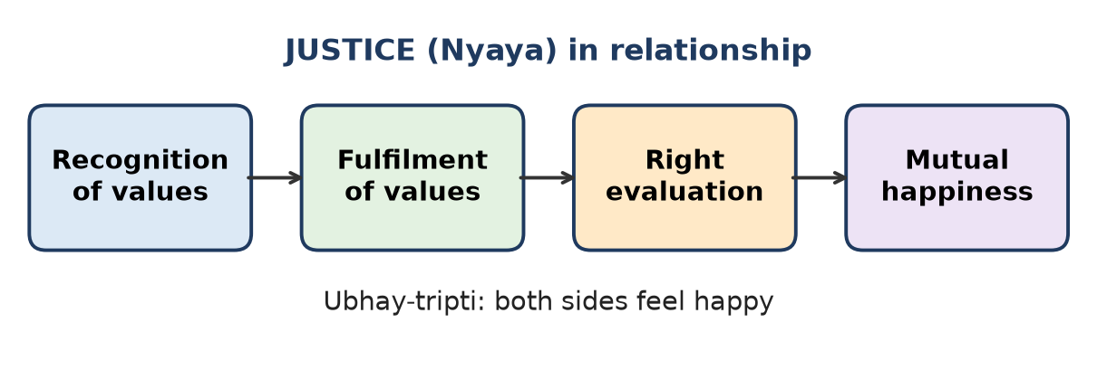
Figure: Four components of justice
Example - teacher and student:
1. Recognition - the teacher recognises the relationship and the values in it (guidance, trust; respect from student).
2. Fulfilment - the teacher guides patiently; the student respects and works sincerely.
3. Evaluation - both evaluate whether the values were fulfilled rightly.
4. Mutual happiness (ubhay-tripti) - both feel satisfied.
Punishment is a correction step only when justice is not ensured.
Remember: Recognise, fulfil, evaluate - both smile.

Q8. A family member supports another during difficulties but expects nothing in return. Identify the human values involved and explain their significance among the nine core human values.
Easy
Values involved:
1. Affection (sneh) - feeling of being related to the other; "you are mine".
2. Care (mamta) - feeling of responsibility to nurture and protect the body of the relative.
3. Love (prem) - expecting nothing in return shows the feeling of being related to all, the complete value.
4. Trust (vishwas) underlies it - assurance that the other wants my happiness.
Significance: Among the nine values (trust, respect, affection, care, guidance, reverence, glory, gratitude, love), trust is the foundation and love is the complete value. Selfless support fulfils relationships and leads to mutual happiness; the person helped naturally feels gratitude.
Remember: Help without hook = affection + care growing into love.

Q9. Rahul considers marriage mainly as a means of fulfilling physical needs, while his parents explain it as a relationship for mutual fulfillment and family development. Critically examine both views.
Easy
Point | Rahul's view | Parents' view
Basis | Body / sensation | Self ('I') and relationship
Purpose | Physical needs | Mutual fulfilment, family development
Duration | Temporary satisfaction | Lifelong commitment
Values | Not considered | Trust, respect, affection, care, loyalty
Result | Dissatisfaction, conflict | Mutual happiness, healthy children

Examination: Rahul's view sees only the Body; physical needs are real but temporary, so marriage based only on them becomes unstable. The parents' view matches the purpose of marriage: two persons committed to each other's growth, building a family and passing on values to children. Marriage is a relationship of the Self, with physical needs as one part.
Remember: Marriage is a meeting of two selves, not just two bodies.

Section B: Moderate Questions

Q10. A father repeatedly tells his child to speak respectfully but frequently speaks rudely to others. Explain why parenting is demonstration rather than mere instruction.
Moderate
Situation: The father's words and behaviour do not match.
Concept: Children receive sanskar (values, conduct) mostly by observing and imitating parents - parenting is living example.
Analysis:
1. Children copy actions - the child learns rude speech by watching the father, not polite speech from his words.
2. Mixed message - words say "respect", actions say "disrespect"; the child learns that values are only for talking.
3. Trust is lost - the child sees the parent as inconsistent and stops taking advice seriously.
4. Pre-conditioning - early years shape the child's beliefs about right behaviour.
5. Right parenting - first live with Right Understanding, then guide (vatsalya). Instruction works only when backed by demonstration.
Instruction only | Demonstration
"Speak politely" | Father speaks politely to everyone
Child confused | Child copies naturally
Weak trust | Strong trust and respect

Solution: The father should speak respectfully to all, admit mistakes, and show values in daily life.
Remember: Children hear our actions louder than our words.

Q11. A student desires to become the class topper and starts comparing himself constantly with others. Analyze how desire influences his behavior.
Moderate
Situation: Desire to be topper → constant comparison.
How desire influences behaviour:
1. Source - desire comes from pre-conditioning (topper = respected) and sensation of praise, not from understanding.
2. Comparison - others become competitors, not co-learners; he feels small when someone scores more.
3. Fear - fear of losing rank follows desire (fear is shadow of desire).
4. Relationship damage - jealousy, hiding notes, no group study; trust reduces.
5. Narrow learning - studies for marks only, not understanding.
6. Unhappiness - even after topping, worry about staying on top continues.
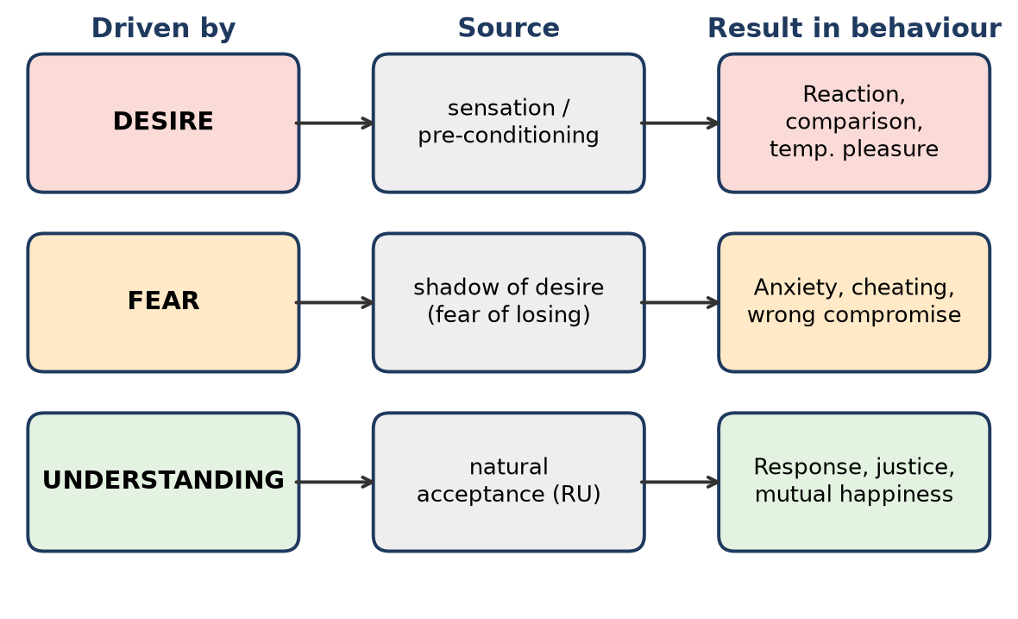
Figure: Behaviour driven by desire, fear or understanding
Understanding-based alternative: Aim at excellence in understanding and helping others learn; compare with your own past, not with others. Marks then come as a by-product, with peace.
Remember: Compete with yesterday's self, not with today's friend.

Q12. A faculty member knows the right decision but avoids taking it because of fear of losing popularity. Explain how fear can influence human behavior.
Moderate
Situation: Fear of losing popularity stops a right decision.
How fear influences behaviour:
1. Paralyses action - the person knows what is right but cannot act on it.
2. Compromise of values - justice and responsibility are sacrificed for image.
3. Reaction, not response - decisions follow others' expectations, not Right Understanding.
4. Inner conflict - knowing vs doing creates guilt and unrest in the Self.
5. Loss of trust - students and colleagues may later lose respect for the faculty.
6. Root - fear is the shadow of the desire for popularity (seeking respect from outside).
Fear-based | Understanding-based
"Will students dislike me?" | "What is right for students?"
Avoid decision | Take fair decision, explain reasons
Short-term popularity | Long-term trust and respect

Solution: Base decisions on justice and mutual fulfilment; explain the reason calmly. Real respect comes from right evaluation, not popularity.
Remember: Fear asks "what will they think?"; understanding asks "what is right?".

Q13. Two students face the same disagreement. One reacts angrily, while the other tries to understand the situation and resolve it peacefully. Which behavior is understanding-based? Justify.
Moderate
The second student's behaviour is understanding-based.
Justification:
1. Response vs reaction - the first student reacts from sensation or ego; the second responds after understanding.
2. Trust in intention - the second student assumes the other also wants happiness (trust); only competence or understanding differs. The angry student doubts the intention.
3. Focus on solution - understanding seeks mutual happiness; anger seeks to win.
4. Harmony in Self - the calm student keeps inner harmony; anger creates disharmony in both.
5. Relationship - peaceful resolution protects the relationship; anger damages it.
Angry reaction | Understanding-based response
Driven by ego/sensation | Driven by Right Understanding
Blames person | Understands situation
Win-lose | Win-win (ubhay-tripti)
Relationship hurt | Relationship strengthened

Remember: Reaction is instant; response is intelligent.

Q14. Neha spends the entire evening watching entertainment videos and feels happy temporarily but dissatisfied afterward. Differentiate temporary pleasure and happiness in this case.
Moderate
Situation: Videos give a short good feeling followed by dissatisfaction.
Point | Temporary pleasure (videos) | Happiness
Source | Sensation through eyes and ears | Harmony in Self and relationships
Duration | Ends with the video | Continuous
Dependence | Depends on device and content | Independent of things
Repetition | Needs more, gives less | Does not reduce
After-effect | Tiredness, guilt, wasted time | Peace, satisfaction
Need fulfilled | Body/senses | Self ('I')

Why Neha feels dissatisfied: The Self's need for happiness is not met by sensation; she also senses that time for study, family or rest was lost, causing inner disharmony.
Better way: Use videos with sanyam (limited time); spend time in learning, talking with family, exercise - activities that bring harmony.
Remember: Screens entertain the senses; harmony satisfies the Self.

Q15. A son expects his parents to provide everything but does not recognize their efforts. Identify the missing expectation in the relationship and explain how it can be fulfilled.
Moderate
Situation: The son takes but does not recognise.
Missing values: Gratitude (kritagyata) and respect/reverence towards parents - and the recognition of the relationship itself.
Analysis:
1. Every relationship has mutual expectations - parents expect respect, gratitude and responsibility; children expect care and guidance.
2. The son sees parents only as providers of physical facility, not as relatives with feelings.
3. This is injustice - values are not recognised, so there is no mutual happiness.
4. Parents feel hurt; trust weakens.
How it can be fulfilled:
- Recognise the effort - parents' time, money, sacrifice and guidance.
- Express gratitude - in words and behaviour (thanking, helping at home).
- Take responsibility - study sincerely, care for parents' health, share decisions.
- Spend time - talk, listen, involve them.
- Right understanding - see the relationship as mutual fulfilment, not a supply chain.
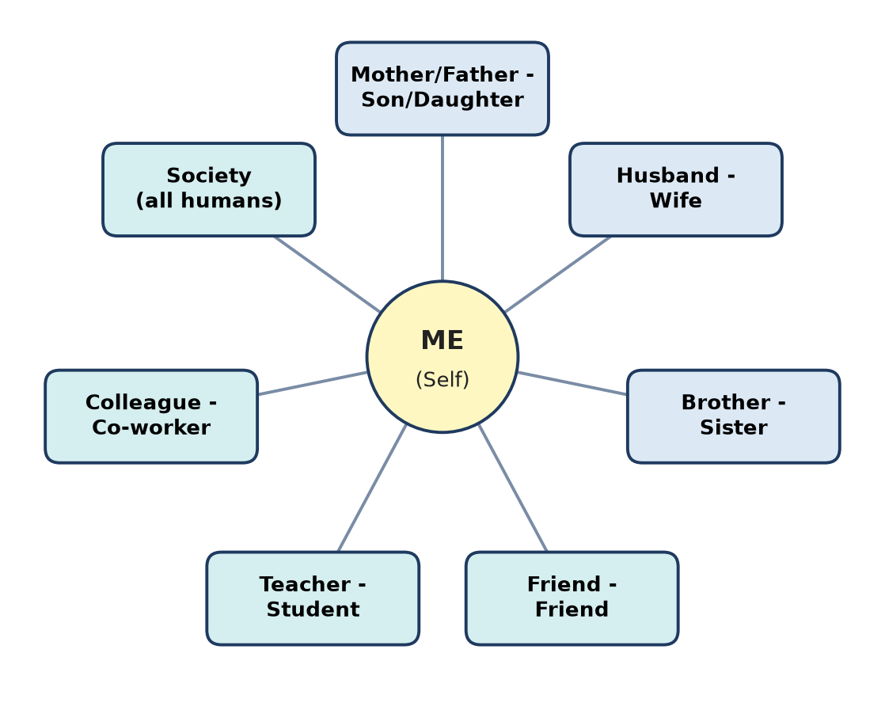
Figure: Seven relationships - each has definite expectations
Remember: Recognise to be recognised; gratitude completes the circle.

Q16. A student shares a personal difficulty with a friend because she believes the friend will not misuse the information. Identify the value demonstrated and explain its role in friendship.
Moderate
Value demonstrated: Trust (vishwas) - the foundational value in relationships.
Meaning: Trust is to be assured that the other person intends my happiness and prosperity, just as I intend theirs.
Role of trust in friendship:
1. Openness - friends share problems, fears and plans without hesitation.
2. Support - help comes at the right time because the need is known.
3. No fear - no fear of being judged, cheated or exposed.
4. Base for other values - respect, affection and care grow on trust.
5. Mutual happiness - both feel secure and related.
Intention vs competence: We should trust the friend's intention (always good) even if their competence (ability) sometimes falls short. Doubting intention breaks friendship.
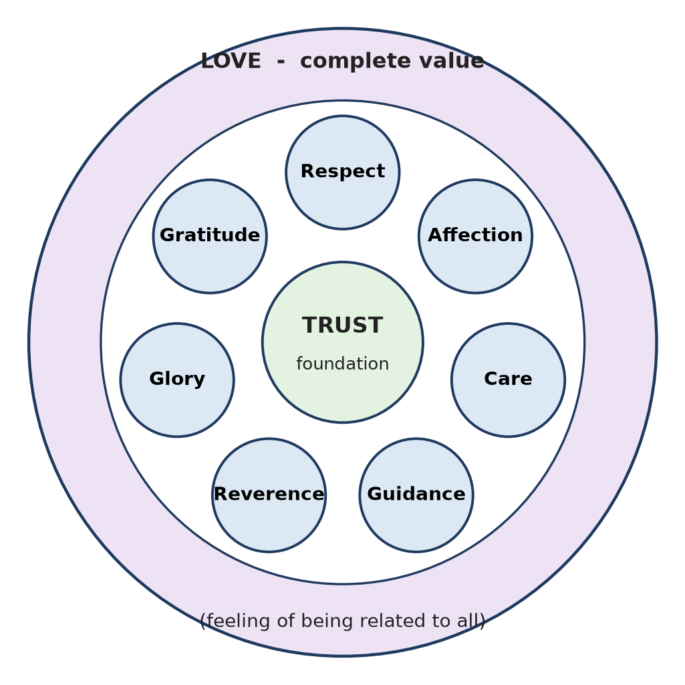
Figure: Nine values - trust as foundation
Remember: No trust, no friendship - trust is the first brick.

Q17. A teacher respects every student equally, but students respect only those who score high marks. Analyze the difference between respect and evaluation based on comparison.
Moderate
Respect (samman) = right evaluation - seeing the other as a human being like me: same purpose (happiness), same program (RU, relationship, PF) and same potential (to understand). Differences are only in competence at present.
Evaluation based on comparison judges people by body, physical facility or performance (marks, money, looks) and ranks them high or low.
Respect (teacher) | Comparison-based evaluation (students)
Based on the Self ('I') | Based on marks
Equal for all | High for toppers, low for others
Builds confidence | Builds pride or inferiority
Leads to harmony | Leads to jealousy, groups
Right evaluation | Over / under / otherwise evaluation

Analysis: The teacher's view is right - every student is equal in dignity. Students' comparison creates disrespect and hurts relationships. Marks show a skill level, which can be improved with guidance.
Remember: Respect counts humans; marks count answers.

Q18. An elderly parent becomes ill, and the son rearranges his schedule to support the parent. Which human values are demonstrated? Explain their relationship with responsibility.
Moderate
Values demonstrated:
1. Care (mamta) - feeling of responsibility to nurture and protect the parent's body (health, food, medicine).
2. Affection (sneh) - feeling of being related; "my parent's problem is my problem".
3. Gratitude (kritagyata) - towards the parent who made efforts for his growth.
4. Reverence (shraddha) - acceptance of the parent's excellence and role.
Relationship with responsibility:
- In UHV, feelings lead to responsibility: when I feel related, I naturally take responsibility - no outside force is needed.
- Care is directly the feeling of responsibility for the Body of a relative.
- Responsibility based on values is joyful, not a burden; duty imposed from outside feels heavy.
- Fulfilling these values ensures justice in the family and mutual happiness.
Remember: Where there is feeling, responsibility follows naturally.

Q19. Two siblings frequently disagree but continue to support each other during difficult situations. Explain how affection can exist even when differences of opinion are present.
Moderate
Affection (sneh) is the feeling of being related to the other - accepting the other as one's own. It is a feeling of the Self, not dependent on agreeing on every opinion.
How affection exists with differences:
1. Opinions belong to thoughts; affection belongs to feelings - different levels.
2. Trust in intention - siblings know each other wants good; only views differ.
3. Respect - accepting the right of the other to think differently.
4. Support in difficulty - shows that the relationship is deeper than arguments.
5. Differences can help - open discussion leads to better understanding when there is no ego.
6. Affection is lost only when the other is seen as an opponent, not when opinions differ.
Tip: Disagree on the issue, never on the relationship - this keeps justice and mutual happiness.
Remember: Opinions differ, belonging stays.

Q20. A student helps his classmate understand a difficult topic instead of simply giving the answer. Explain how this action can contribute to justice and mutual happiness.
Moderate
Situation: Helping a peer understand, not just copy.
Concept: Justice = recognition, fulfilment and evaluation of values leading to mutual happiness; guidance (vatsalya) = ensuring right understanding in the other.
How it ensures justice:
1. Recognition - the helper recognises the friend's real need is understanding, not an answer.
2. Fulfilment - he gives guidance and care for the friend's growth.
3. Right evaluation - he sees the friend as capable of understanding (respect), not as weak.
4. Mutual happiness - the friend gains confidence and competence; the helper deepens his own understanding and feels fulfilled.
Why not just give the answer: It creates dependence, gives only short relief and does not develop the friend - this is not real help.
Wider effect: Builds trust and a cooperative class culture instead of competition.
Figure: Justice leading to mutual happiness
Remember: Give understanding, not answers - both grow.

Section C: Application-Based Descriptive Questions – Difficult Questions

Q21. A couple decides important family matters through mutual understanding rather than domination by one partner. Explain how this reflects the purpose of marriage and right relationship.
Difficult
Situation: Husband and wife decide together - no one dominates.
Concepts: Purpose of marriage; right marital relationship; values; justice.
Purpose of marriage: Two persons commit to mutual fulfilment - each helps the other's understanding and happiness - and together they build a family, raise children with values and contribute to society.
How the couple's behaviour reflects it:
1. Trust - each trusts the other's intention for family good.
2. Respect - both seen as equal in dignity; roles differ, worth does not.
3. Shared responsibility - decisions on money, children, parents are joint.
4. Justice - feelings and views of both are recognised and fulfilled → ubhay-tripti.
5. Good example for children - children learn cooperation, not domination.
Domination | Mutual understanding
One decides, other obeys | Both discuss and agree
Fear, resentment | Trust, respect
Hidden conflict | Open communication
Children learn power | Children learn harmony

Problems avoided: ego clashes, gender inequality, financial disputes, lack of trust - common causes of marital conflict.
Conclusion: The couple lives the right marital relationship - commitment, loyalty and mutual growth.
Remember: Marriage is a partnership of equals, not a chain of command.

Q22. In a family, household responsibilities are assigned only according to gender. Analyze the situation from the perspective of dignity and equality.
Difficult
Situation: Cooking/cleaning for women, outside work for men - fixed by gender.
Concepts: Gender equality in dignity; respect as right evaluation; justice in family.
Analysis:
1. Wrong evaluation - judging capability by body (gender), not by the Self. In the Self ('I'), men and women are equal - same aspiration, same potential.
2. Difference in role ≠ difference in dignity - roles can differ by ability, interest and situation, but both must be equally valued.
3. Overburden - often women carry home work plus jobs; this is injustice.
4. Lost growth - boys miss life skills, girls miss opportunities.
5. Children learn bias - pre-conditioning continues to the next generation.
6. Relationship strain - resentment replaces mutual happiness.
Gender-fixed roles | Understanding-based roles
Based on body | Based on ability, time, mutual agreement
Unequal burden | Shared responsibility
One role valued more | All work equally respected
Resentment | Mutual happiness

Solution:
- Discuss and share tasks by ability and availability.
- Respect all work - household work is equally valuable participation.
- Parents demonstrate sharing so children learn equality.
Conclusion: Responsibilities must be shared with equal dignity; this ensures justice and harmony in the family.
Remember: Roles may differ; respect must not.

Q23. Parents regularly discuss honesty with their children but themselves provide false information to others. Critically analyze the likely impact of this behavior on the child.
Difficult
Situation: Parents preach honesty but practise lying.
Concept: Parenting = demonstration; children learn sanskar by observing.
Likely impact on the child:
1. Confusion - words and actions conflict; the child does not know which is right.
2. Learning dishonesty - the child copies behaviour ("lying is fine when useful").
3. Loss of trust and respect - the child sees parents as hypocritical; guidance loses value.
4. Double standards - honesty becomes "something to talk about", not to live.
5. Fear-based behaviour - the child may lie to avoid punishment, as parents lie to avoid trouble.
6. Long-term effect - weak character; may cheat in exams, work or relationships.
7. Inner conflict - natural acceptance says honesty is right; observed behaviour says otherwise → disharmony.
Words only | Words + example
Child confused | Child clear
Values are rules | Values are natural
Trust weak | Trust strong

Right approach:
- Parents live honestly, even in small matters (tickets, bills, excuses).
- Admit mistakes openly - teaches responsibility.
- Explain why honesty leads to trust and mutual happiness.
Conclusion: The child will most likely learn what parents do, not what they say; consistent example is the real teaching.
Remember: Values are caught more than taught.

Q24. A student wants an expensive motorcycle, fears that friends may consider him unsuccessful, and purchases it mainly for social recognition. Identify the roles of desire, fear, and sensation.
Difficult
Situation: Costly bike bought for image.
Role of each factor:
1. Sensation - looks, sound, speed, ads and seeing others ride create attraction through the senses.
2. Desire - from sensation and pre-conditioning ("bike = success, status"), a desire arises to own it.
3. Fear - the shadow of desire: fear that friends will see him as unsuccessful if he does not have it.
4. Result - decision is made for social recognition, not need; it is sensation- and fear-driven behaviour, not understanding-driven.
Figure: Behaviour driven by desire, fear or understanding
Consequences:
- Financial burden on family; possible debt.
- Temporary excitement, then new comparisons (better bike, better phone).
- Respect gained is false - based on things, not the person.
- Possible risk to safety (show-off riding).
Understanding-based response:
- Ask: Do I need a vehicle? Which is sufficient and affordable?
- Understand that respect comes from right evaluation of a person - character, competence, behaviour.
- Real friends value the person, not the bike.
- Choose according to need, decide with family.
Conclusion: Sensation triggers, desire drives and fear pushes - only Right Understanding can break this chain.
Remember: Bought for image, paid in peace.

Q25. A company promotes an employee only because of his technical performance, ignoring his honesty and responsibility. Critically examine whether this represents complete evaluation of the person.
Difficult
Situation: Promotion based only on technical skill.
Concept: Right (complete) evaluation sees the whole human being - competence (skills) and values/character (honesty, responsibility, behaviour). Partial evaluation leads to wrong decisions.
Critical examination:
1. Incomplete - technical performance shows competence, but not intention or character.
2. Risk to organisation - a skilled but dishonest manager may misuse power, data or money.
3. Team relationships - lack of responsibility and trust damages teamwork and morale.
4. Wrong message - employees learn that values do not matter, only output.
5. Injustice - honest and responsible employees feel undervalued.
6. Long-term - organisations fail more from ethical failures than from technical ones.
Partial evaluation | Complete evaluation
Skills only | Skills + values + behaviour
Short-term output | Long-term trust and growth
Ignores relationships | Considers team harmony

Better approach:
- Evaluate on competence + honesty + responsibility + teamwork.
- Give guidance and training to develop values where needed.
- Promote people who can lead with trust and justice.
Conclusion: It is not complete evaluation; a person is more than skill, and leadership needs both competence and character.
Remember: Skill earns a job; character earns trust.

Q26. Two brothers argue about the division of family responsibilities because each believes the other should do more. Explain how recognition, fulfillment, and evaluation can help resolve the conflict.
Difficult
Situation: Each brother thinks the other should do more - blame instead of sharing.
Concept: Justice = recognition of values → fulfilment → right evaluation → mutual happiness.
Steps to resolve:
1. Recognition
- Recognise the relationship - both are brothers with shared responsibility to parents and family.
- Recognise values: trust, affection, care for each other and for parents.
- Recognise each other's situation (job hours, location, health).
2. Fulfilment
- Discuss openly and divide tasks by ability and availability (one handles finances, the other doctor visits).
- Fulfil feelings - appreciate each other's effort.
3. Evaluation
- Review together after some time: Are parents cared for? Is the load fair? Is anyone hurt?
- Evaluate self first: "Am I fulfilling my part?" rather than checking the other.
4. Mutual happiness - both feel fairly treated; parents feel cared for.
Figure: Justice process
Without justice | With justice
Blame, comparison | Recognition and sharing
"You should do more" | "What can I do?"
Strained relationship | Strengthened bond

Conclusion: Moving from expectation from the other to responsibility of self resolves the conflict.
Remember: Recognise, fulfil, evaluate - start with yourself.

Q27. A teacher patiently guides a weak student, while the student sincerely follows the teacher's guidance. Identify the values operating in this relationship and explain their importance.
Difficult
Situation: Patient teacher, sincere student - a fulfilling teacher-student relationship.
Values from the teacher's side:
1. Guidance (vatsalya) - feeling of responsibility to ensure right understanding and feelings in the student.
2. Care (mamta) - concern for the student's growth and well-being.
3. Respect (samman) - seeing the weak student as equally capable, not inferior.
4. Affection (sneh) - feeling of being related.
Values from the student's side:
1. Trust (vishwas) - believes the teacher's intention is his good.
2. Respect / Reverence (shraddha) - acceptance of the teacher's excellence.
3. Gratitude (kritagyata) - for the teacher's effort for his growth.
4. Glory (gaurav) - may feel for a teacher who works for others' excellence.
Importance:
- Trust is the foundation - without it, guidance is not accepted.
- Guidance + sincerity leads to real learning and confidence.
- Justice is ensured - values fulfilled on both sides → mutual happiness.
- The student may later guide others - values pass on.
Teacher gives | Student gives
Guidance, care, respect | Trust, reverence, gratitude

Conclusion: When values flow both ways, the relationship becomes a source of growth and happiness for both.
Remember: Teacher guides, student trusts - learning flows.

Q28. During an examination, a student is tempted to cheat because of fear of failure. Explain how understanding-based behavior could help the student respond differently.
Difficult
Situation: Fear of failure → temptation to cheat.
Concept: Behaviour may be driven by desire, fear or understanding. Fear-driven behaviour leads to wrong compromises; understanding-driven behaviour is definite and right.
Fear-based thinking: "If I fail, parents will scold, friends will laugh, my future is over." → cheating seems like a solution.
Understanding-based response:
1. Purpose of exam - to check understanding, not just to get marks. Cheating defeats the purpose.
2. Natural acceptance - inside, every person accepts honesty as right; cheating creates guilt and disharmony.
3. Right evaluation of self - one exam does not define a person's worth; failure is feedback.
4. Consequences - if caught: disgrace, debarment; even if not: weak knowledge, broken self-trust.
5. Trust in relationships - parents and teachers trust the student; cheating breaks it.
6. Constructive action - attempt honestly what is known, learn from mistakes, seek guidance, plan better.
Fear-driven | Understanding-driven
Cheats to avoid failure | Writes honestly
Short-term relief | Long-term confidence
Guilt, fear of being caught | Peace, self-respect

Conclusion: Understanding converts fear into clarity and courage, so the student chooses honesty.
Remember: Cheating hides the problem; understanding solves it.

Q29. A student has good academic performance, a successful career, many material possessions, but remains dissatisfied and fearful about losing his status. Analyze the situation using Right Understanding (RU), Relationship (R), and Physical Facility (PF).
Difficult
Situation: Academic + career success + possessions, yet dissatisfied and fearful - the SSDD state (has facilities, still unhappy and deprived).
Analysis:
1. Physical Facility (PF) - plenty, but PF fulfils only the Body. Without RU, he cannot define how much is enough, so never feels prosperous.
2. Right Understanding (RU) - missing
- He believes status and things bring happiness - a wrong assumption.
- Happiness is a need of the Self, fulfilled by harmony.
- Fear of losing status = fear as shadow of desire (desire for recognition).
3. Relationship (R) - weak
- Respect is sought through status, not through right evaluation.
- Relationships may be based on use or competition, not trust.
- Lack of affection and trust leaves the Self unfulfilled.
Requirement | Present state | Needed
RU | Absent | Self-exploration, clarity of goal
R | Weak, status-based | Trust, respect, affection
PF | Plenty | Identified need → prosperity

Figure: Right priority RU, R, PF
Solution:
- Self-reflection - understand the real source of happiness.
- Build relationships on trust; spend time with family and friends.
- Define needs; share surplus; feel prosperity.
- See work as contribution, not just status.
Conclusion: He has only the third requirement; with RU and R in priority, his success becomes life success.
Remember: Status without understanding = success with fear.

Q30. A family has sufficient physical facilities but frequent conflicts among parents, children, and siblings. Members also experience comparison, fear, and dissatisfaction. Using the concepts of human behavior, relationships, justice, values, marriage, and parenting, identify the major issues and suggest an understanding-based approach for creating mutual happiness.
Difficult
Situation: Facilities are enough; harmony is missing.
Major issues:
1. Behaviour - driven by desire, sensation and fear, not understanding; reactions instead of responses.
2. Wrong priority - PF given first; RU and relationships neglected.
3. Relationships - lack of trust (doubting intention), lack of respect (comparison among siblings).
4. Injustice - values not recognised or fulfilled; no mutual happiness.
5. Marriage - parents may be in conflict, lacking shared decisions and mutual fulfilment.
6. Parenting - children copy conflict and comparison; values are instructed, not demonstrated.
Understanding-based approach:
Area | Action
Behaviour | Pause, understand before reacting; self-reflection by each member
Priority | RU → R → PF; spend time, not only money
Values | Practise trust in intention, respect without comparison, affection, care, gratitude
Justice | Recognise each other's feelings, fulfil them, evaluate together - weekly family talk
Marriage | Parents decide jointly, respect each other, show unity
Parenting | Live the values; appreciate each child for who they are

Figure: Nine values in relationships
Expected result: Fear and comparison reduce, trust grows, children learn by example and the family moves from SSDD to sampanna-sukhi-samriddha.
Conclusion: Physical facilities cannot create harmony; Right Understanding lived in relationships creates mutual happiness.
Remember: A happy family is built on understanding, held by trust, and comforted by facility.

Quick Revision – Unit 2
Term | Key fact
Purposeful participation | Acting with clear purpose of mutual fulfilment
Three drivers of behaviour | Desire, fear, understanding
Fear | Shadow of desire
Sensation-driven behaviour | Acting on attraction of senses without understanding
Pre-conditioning | Beliefs assumed from society without verification
Seven relationships | Parent-child, husband-wife, siblings, friends, teacher-student, colleagues, society
Nine values | Trust, respect, affection, care, guidance, reverence, glory, gratitude, love
Trust | Foundation value; trust intention, check competence
Respect | Right evaluation; other is like me
Love | Complete value; feeling of being related to all
Justice | Recognition, fulfilment, evaluation → mutual happiness
Ubhay-tripti | Mutual happiness of both sides
Purpose of marriage | Mutual fulfilment and family development
Parenting | Demonstration, not just instruction
Gender | Difference in role ≠ difference in dignity

Unit 3: Wisdom & Universal Harmony (Holistic Living)

A. Easy Questions

Q1. Explain the meaning of Knowledge, Wisdom and Science in the context of human living.
Easy
1. Knowledge (Gyan) - right understanding of what is: understanding of the Self ('I'), of existence (co-existence of all units) and of human conduct. It answers "What is reality?"
2. Wisdom (Vivek) - the ability to use this understanding to decide what to do and why - the right purpose and the right choice in living. It answers "What is right for mutual fulfilment?"
3. Science (Vigyan) - knowledge of how to do - methods, measurement, techniques and technology for fulfilling the purpose. It answers "How?"
For complete living, science must be guided by wisdom, and wisdom by knowledge.
Remember: Gyan = what is, Vivek = why/what, Vigyan = how.

Q2. Explain the relationship Knowledge → Wisdom → Science.
Easy
The three form a chain: each step depends on the one before it.
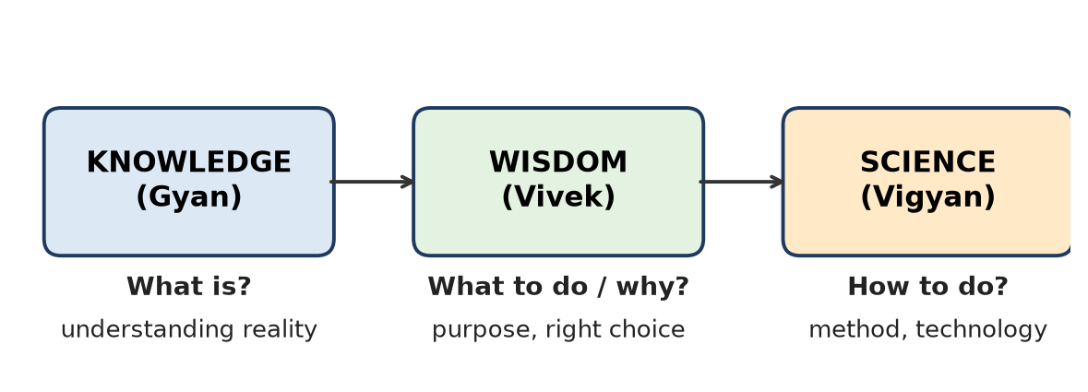
Figure: Knowledge → Wisdom → Science
1. Knowledge → Wisdom - when I understand reality (Self, existence, conduct), I can see the right purpose of life - mutual fulfilment.
2. Wisdom → Science - once purpose is clear, science provides the means (how) to achieve it.
3. Science without wisdom - powerful but directionless; it may produce pollution, weapons, exploitation.
Example: Knowing that humans and nature are inter-related (knowledge) → choosing clean energy (wisdom) → designing a solar plant (science).
Remember: Understanding sets the aim; science supplies the arrow.

Q3. Define sustainable living according to Madhyasth Darshan.
Easy
Sustainable living in Madhyasth Darshan is living with Right Understanding in harmony with all four orders of nature (material, plant, animal, human), so that human needs are fulfilled through mutual fulfilment and cyclicity, without exploitation, and the same can continue for all future generations.
Key features:
- Needs identified with RU (no greed).
- Production that is cyclic, eco-friendly and recyclable.
- Relationships of trust in society.
- Enrichment, protection and right utilisation of nature.
Remember: Sustainable = fulfil now, fulfil forever, fulfil all.

Q4. Explain the meaning of prosperity in Madhyasth Darshan.
Easy
Prosperity (Samriddhi) is the feeling of having or making more than the required physical facilities.
1. It is a feeling in the Self, not just a quantity of wealth.
2. It needs two things: identifying needs (with Right Understanding) and producing/earning more than that need.
3. A prosperous person shares and does not hoard or exploit.
4. Prosperity is the human goal at the family level.
Example: A farmer family that grows more than it needs and shares the extra feels prosperous; a billionaire who always wants more feels deprived.
Remember: Prosperity = need known + more than need.

Q5. Differentiate between need and greed with one suitable example.
Easy
Need | Greed
What is truly required for Self or Body | Wanting more than required, without limit
Limited, definite | Unlimited
Decided by Right Understanding | Driven by desire, comparison, fear
Fulfilment gives satisfaction, prosperity | Fulfilment gives more craving
Leads to sharing | Leads to hoarding, exploitation

Example: A family needs one comfortable house - that is need. Buying five flats to hold empty while others have no shelter - that is greed.
Remember: Need has a full stop; greed has none.

Q6. Explain the meaning of holistic living.
Easy
Holistic living means living with the understanding that everything is inter-connected - Self, family, society, nature and existence - and acting so that there is harmony at all these levels.
- In the Self: right understanding, right feelings.
- In family: trust, prosperity.
- In society: fearlessness, justice.
- In nature: mutual fulfilment, co-existence.
It is the opposite of a fragmented view (only career, only money, only my comfort).
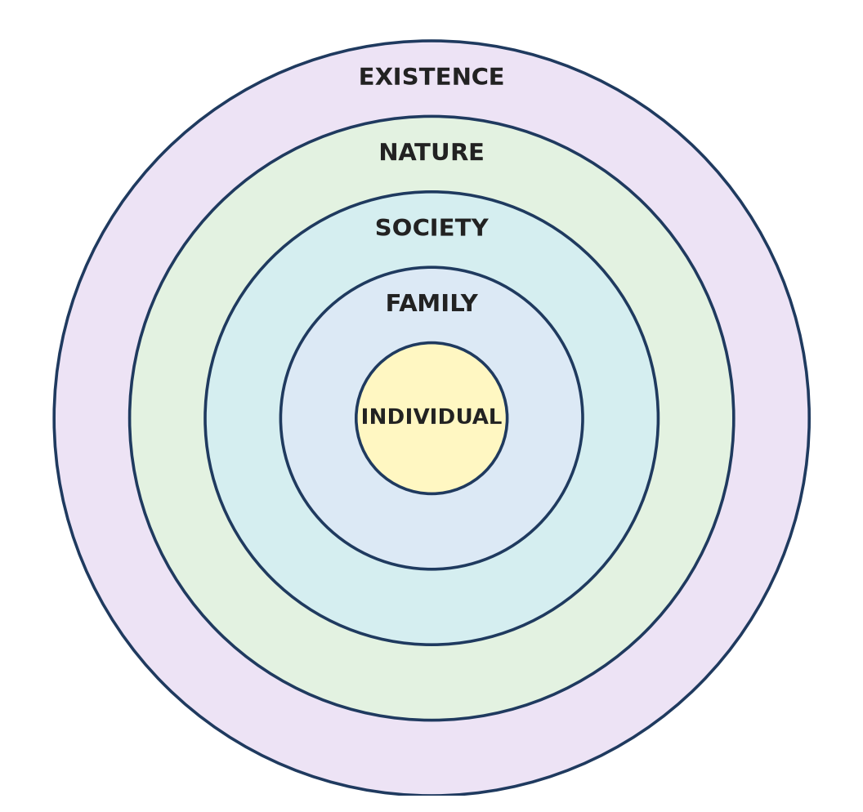
Figure: Levels of harmony in holistic living
Remember: Holistic = seeing and serving the whole.

Q7. List and explain the four dimensions of the human goal.
Easy
The comprehensive human goal has four parts, at four levels:
1. Resolution (Samadhan) - in every individual: right understanding, freedom from confusion and problems.
2. Prosperity (Samriddhi) - in every family: feeling of having more than required physical facility.
3. Fearlessness / Trust (Abhay) - in society: mutual trust, no fear among people.
4. Co-existence (Sah-astitva) - in nature/existence: harmony and mutual fulfilment with all four orders.
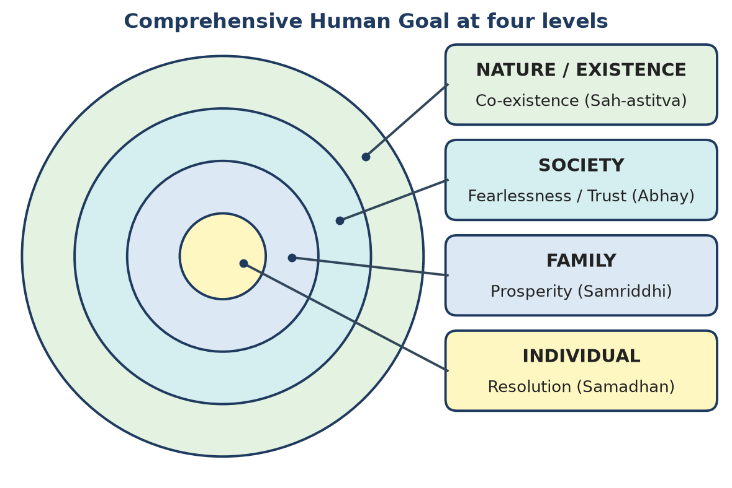
Figure: Human goal at four levels
Remember: R-P-F-C: Resolve, Prosper, Fear-not, Co-exist.

Q8. Explain the meaning of Resolution as a dimension of the human goal.
Easy
Resolution (Samadhan) is the state in which a person has right understanding and therefore no confusion or conflict within - all questions are answered by understanding.
1. It is the human goal at the individual level.
2. It comes through self-exploration - verifying on natural acceptance.
3. It removes problems (samasya) - fear, doubt, contradiction in thoughts.
4. It is the base of the other three goals: a resolved person builds a prosperous family, trusting society and lives in co-existence.
Example: An engineer clear about ethics does not get confused when offered a bribe.
Remember: Resolution = clarity inside, no conflict.

Q9. Explain the meaning of Fearlessness in a harmonious society.
Easy
Fearlessness (Abhay) is the state of society in which every person trusts every other - there is no fear of being cheated, harmed or exploited.
1. It is the human goal at the society level.
2. It comes from right understanding in individuals, trust and justice in relationships and prosperity in families.
3. Fear arises when people doubt each other's intention and compete for resources.
4. In a fearless society, police and locks are needed less; cooperation increases.
Example: In a community where everyone is honest, people help strangers freely.
Remember: Fearlessness = trust spread across society.

Q10. Name the five dimensions of human participation and briefly explain them.
Easy
The five dimensions of the universal human order through which humans participate in society:
1. Education - Sanskar (right living) - developing right understanding and right conduct.
2. Health - Sanyam (self-regulation) - Self takes responsibility for the Body; body stays healthy.
3. Justice - Protection (preservation) - ensuring justice in relationships; protecting people and nature.
4. Production - Work - producing physical facilities through work, in harmony with nature.
5. Exchange - Storage - exchanging for mutual fulfilment (not profit) and storing for future use (not hoarding).
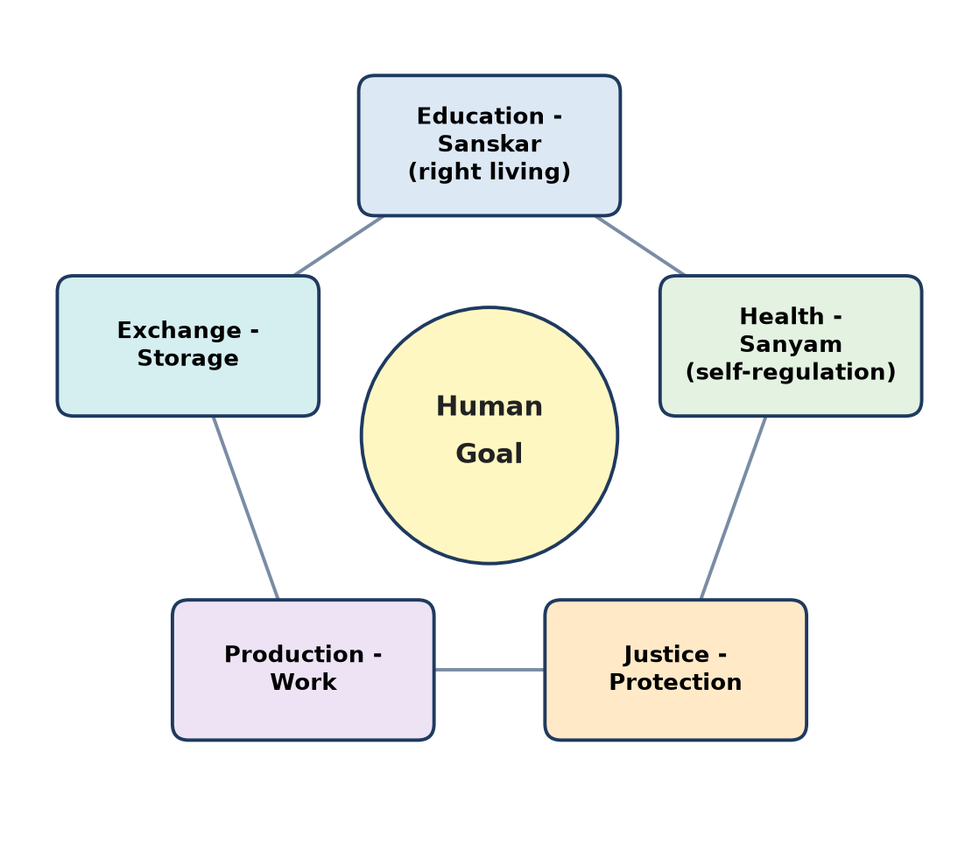
Figure: Five dimensions of human order
Remember: E-H-J-P-E: Educate, Heal, Judge-fairly, Produce, Exchange.

Q11. Name and explain the four orders in nature.
Easy
Order | Examples | Things | Activity | Innateness
Material order (padarth avastha) | Soil, water, air, metals | Matter | Composition / decomposition | Existence
Plant / Bio order (pran avastha) | Grass, trees, crops | Material + respiration | Respiration, growth | Existence + growth
Animal order (jiv avastha) | Cow, dog, birds | Body + Self ('I') | Assuming, recognising, fulfilling | + will to live
Human order (gyan avastha) | Human beings | Body + Self ('I') | Knowing, assuming, recognising, fulfilling | + will to live with happiness

Each higher order includes the lower ones. Material order is largest in quantity; human order is the only one that needs right understanding to be in harmony.
Remember: Material, Plant, Animal, Human - each adds a new quality.

Q12. Explain the meaning of mutual fulfillment among the four orders.
Easy
Mutual fulfilment means that each order fulfils the others and is fulfilled by them, naturally and cyclically.
1. Material → Plant: soil, water, minerals nourish plants.
2. Plant → Material: plants decay and enrich soil; prevent erosion.
3. Plant → Animal: food, shelter, oxygen.
4. Animal → Plant: manure, pollination, seed spreading.
5. Human: gets fulfilment from all three; must enrich, protect and rightly use them in return.
The first three orders are already in mutual fulfilment; humans can join it only with Right Understanding.
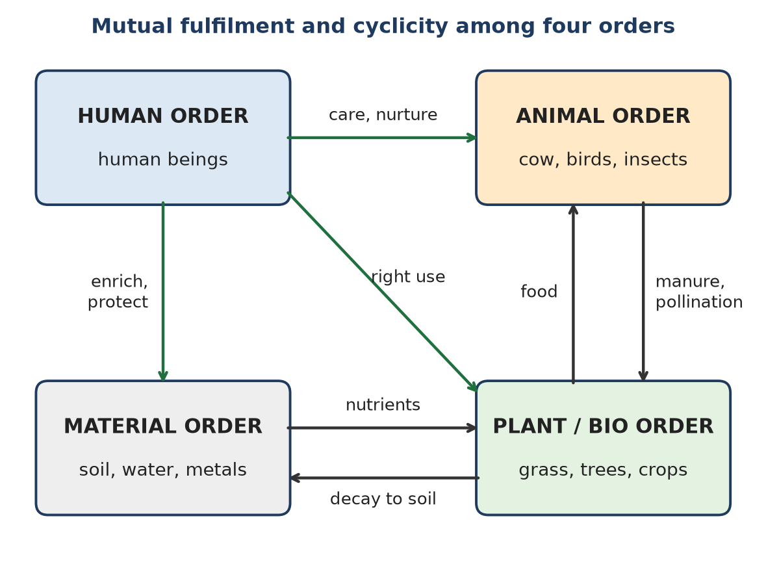
Figure: Mutual fulfilment among four orders
Remember: Nature gives and takes in a circle; humans must join the circle.

B. Moderate Questions

Q13. Explain how right understanding leads to sustainable living.
Moderate
Right Understanding (RU) - understanding harmony in Self, family, society and nature - is the root of sustainable living.
1. Needs are identified - RU tells how much physical facility is needed, so there is no greed or over-consumption.
2. Happiness is not sought from things - happiness comes from harmony, so consumption reduces naturally.
3. Prosperity - producing more than needed creates a feeling of plenty; no need to exploit.
4. Seeing nature as related - the four orders are seen as mutually fulfilling; humans enrich, protect, rightly use them.
5. Right choice of technology - cyclic, renewable, eco-friendly methods are chosen.
6. Trust in society - cooperation replaces competition for resources.
Without RU | With RU
Endless wants | Defined needs
Exploitation of nature | Mutual fulfilment
Competition | Cooperation
Waste | Recycling

Example: A person with RU uses public transport, saves water and repairs instead of replacing - not out of rule, but from understanding.
Remember: RU limits wants and widens care.

Q14. Explain the difference between wealth/physical facility and the feeling of prosperity.
Moderate
Wealth / physical facility is the material thing - money, house, vehicle. Prosperity is the feeling of having or making more than the required physical facility.
Point | Wealth / Physical facility | Prosperity
Nature | Physical, measurable | Feeling in the Self
Need of | Body | Self ('I')
Depends on | Quantity owned | Need identified + production more than need
Can be | Large but still felt "not enough" | Present even with modest wealth
Leads to | Possession, sometimes accumulation | Sharing, generosity, no exploitation

Key point: A rich person without RU may feel deprived (SSDD); a person with modest means and clarity of need feels prosperous.
Example: A teacher family with enough for food, education and savings, which helps neighbours, is prosperous; a businessman always anxious about more profit is wealthy but not prosperous.
Remember: Wealth is what you hold; prosperity is how you feel about it.

Q15. Explain how uncontrolled competition can affect sustainable living.
Moderate
Uncontrolled competition is the race to get more than others - more market share, more consumption, more status - without regard to needs or nature.
Effects on sustainable living:
1. Over-production and over-consumption - products made to beat rivals, not to fulfil needs; heavy waste.
2. Exploitation of nature - forests, minerals, water used faster than they can regenerate.
3. Exploitation of people - low wages, long hours, unsafe work to cut costs.
4. Short-term thinking - quarterly profit over long-term health of society and nature.
5. Breaks trust - others become rivals; fear replaces cooperation (no fearlessness).
6. Inequality - winners hoard, losers are deprived.
Competition | Cooperation (holistic)
Win-lose | Mutual fulfilment
Exploitation | Enrichment, protection
Waste | Recycling

Holistic alternative: Cooperation and excellence - each does their best as contribution; production according to need; fair exchange.
Remember: Race for more = race to empty the earth.

Q16. Describe the holistic approach to sustainable production using the sequence Need → Resource → Production → Utilization → Reuse/Recycle → Natural Restoration.
Moderate
Holistic production is cyclic, like nature, so nothing becomes harmful waste.
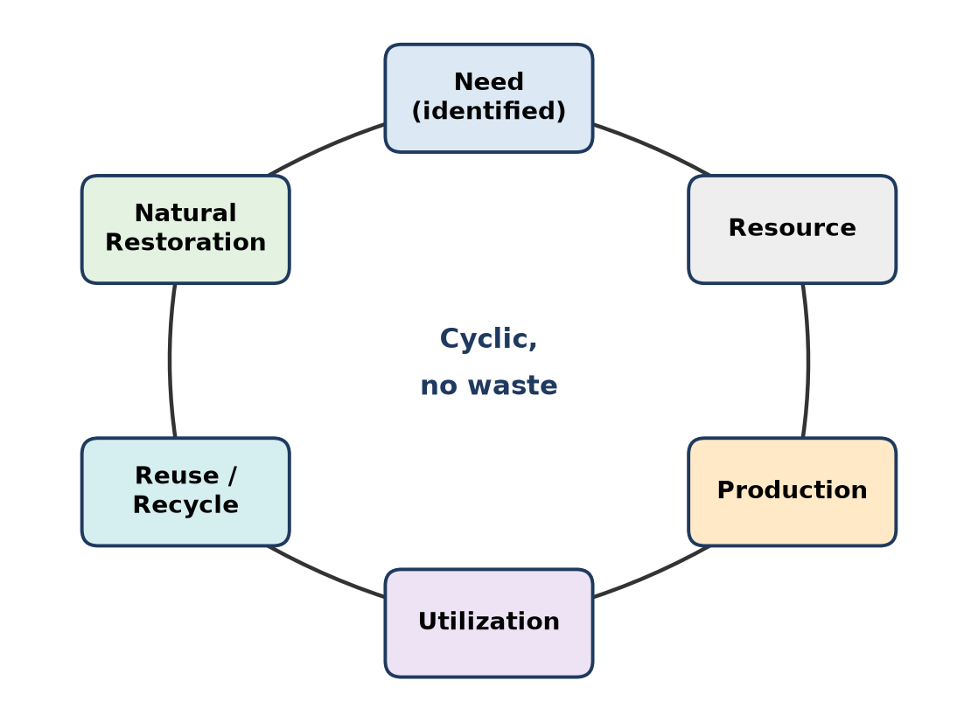
Figure: Sustainable production cycle
1. Need - start by identifying the real need with Right Understanding (not demand created by ads).
2. Resource - choose renewable, local resources; use only what is needed.
3. Production - eco-friendly, people-friendly processes; low energy, low pollution; produce in the right quantity.
4. Utilization - use products fully and carefully; maintain and repair.
5. Reuse / Recycle - after use, reuse parts or recycle materials back into production.
6. Natural Restoration - what cannot be recycled returns to nature in a form nature can absorb (compost, biodegradable); restore soil, water, forests.
Example: Organic farming - need for food → local seeds and compost → crop → eating → crop waste and manure → compost restores soil.
Remember: Need-led, nature-fed, no dead-end waste.

Q17. Explain why technology is neither inherently sustainable nor unsustainable.
Moderate
Technology is a means (science = "how"). Whether it is sustainable depends on the purpose and the way it is used, which is decided by human wisdom (Right Understanding).
1. Same technology, different results - nuclear energy can light cities or destroy them; plastic can save lives in medicine or choke rivers.
2. Purpose decides - technology used for real needs and mutual fulfilment is sustainable; used for greed or excess, it is unsustainable.
3. Scale and quantity - even clean technology becomes harmful if over-used.
4. Design choices - recyclability, energy use, local materials are human decisions.
5. Knowledge → Wisdom → Science - when science is guided by wisdom, technology serves harmony.
Technology | Sustainable use | Unsustainable use
Automobile | Shared/public transport | One person per car, daily
Internet | Learning, remote work | Endless e-waste, addiction
Fertiliser | Balanced, need-based | Excess, soil damage

Remember: Tools are neutral; intentions are not.

Q18. Explain how an individual can practice sustainable living in everyday life with reference to food, water and energy.
Moderate
Food:
1. Take only what you need; avoid wasting food.
2. Prefer local, seasonal, less-processed food.
3. Compost kitchen waste.
4. Eat balanced, healthy meals (sanyam).
Water:
1. Close taps; fix leaks.
2. Use bucket instead of shower; reuse RO reject water for cleaning or plants.
3. Harvest rainwater where possible.
4. Do not pollute water bodies.
Energy:
1. Switch off lights, fans and chargers when not in use.
2. Use LED bulbs, efficient appliances, solar where possible.
3. Walk, cycle or use public transport.
4. Repair and reuse devices instead of frequent replacement.
Basis: These are not just rules; with Right Understanding we see nature as related and practise right utilisation.
Area | Simple daily action
Food | No waste, local food
Water | Fix leaks, reuse
Energy | Switch off, public transport

Remember: Take less, waste nothing, return to nature.

Q19. Explain the transition from "consumer" to "contributor" in Madhyasth Darshan.
Moderate
A consumer sees life as using and acquiring - more goods, more pleasure. A contributor sees life as participating in the larger order - fulfilling others and nature.
Consumer | Contributor
"What can I get?" | "What can I give?"
Driven by desire, sensation | Driven by Right Understanding
Happiness from things | Happiness from harmony
Accumulates, wastes | Produces more than need, shares
Exploits nature | Enriches, protects nature

How the transition happens:
1. Self-exploration - realising that happiness is a need of the Self, not of things.
2. Identifying needs - knowing how much is enough → prosperity.
3. Seeing relationship - with family, society and nature.
4. Right work and participation - production, education, health care as contribution.
Example: An engineer who earlier bought gadgets for status now designs low-cost solar lamps for villages.
Remember: From taking more to giving more.

Q20. Describe the human role in society through right understanding, right feeling, right behaviour, right work and right participation.
Moderate
A human being fulfils their role in society through five linked steps:
1. Right understanding - understanding harmony in Self, family, society, nature; this is in the Self.
2. Right feeling - feelings of trust, respect, affection, care etc. towards others, arising from RU.
3. Right behaviour (vyavahar) - with other humans: expressing right feelings, ensuring justice and mutual happiness.
4. Right work (karya) - with the rest of nature: producing physical facility in a way that enriches and protects nature.
5. Right participation - taking part in the larger order (five dimensions: education, health, justice, production, exchange).
Step | With | Result
Right understanding | Self | Resolution
Right feeling | Self → others | Trust
Right behaviour | Humans | Justice, mutual happiness
Right work | Nature | Prosperity, mutual fulfilment
Right participation | Larger order | Universal human order

Remember: Understand → feel → behave → work → participate.

Q21. Explain how Resolution, Prosperity, Fearlessness and Coexistence are interconnected.
Moderate
The four human goals are linked like a chain, each supporting the next.
1. Resolution → Prosperity - a resolved person knows real needs; the family produces more than needed and feels prosperous.
2. Resolution + Prosperity → Fearlessness - people with clarity and enough don't need to cheat or exploit; trust grows → fearless society.
3. Fearlessness → Co-existence - a trusting society cooperates and treats nature with care → co-existence with all orders.
4. Co-existence → Resolution and Prosperity - harmony with nature sustains resources and peace, supporting individuals and families.
5. Breaking one breaks all - without resolution, greed destroys prosperity, trust and nature.
Figure: Human goal at four levels
Example: A village where people understand needs (resolution), grow enough (prosperity), trust each other (fearlessness) and protect forests and water (co-existence).
Remember: Clear mind → enough at home → trust outside → harmony with nature.

Q22. Explain the role of Education–Sanskar in fulfilling the human goal.
Moderate
Education (Shiksha) is developing right understanding; Sanskar is the commitment and practice of right living based on it. Together, Education–Sanskar is the first and most important dimension.
Role in fulfilling the human goal:
1. Resolution - education for self-exploration gives clarity in every individual.
2. Prosperity - teaches how to identify needs and produce through right skills.
3. Fearlessness - builds values like trust and respect, so people live in justice.
4. Co-existence - teaches understanding of nature and the four orders.
5. Base for other dimensions - health (sanyam), justice, production and exchange all need right understanding first.
6. Continuity - parents and teachers pass on right understanding to the next generation by example.
Education only (skills) | Education + Sanskar
Competence | Competence + values
Job-focused | Life-focused
May serve greed | Serves mutual fulfilment

Remember: Education gives understanding; sanskar turns it into living.

Q23. Explain the relationship between Justice–Protection and fearlessness in society.
Moderate
Justice (Nyaya) = recognition, fulfilment and evaluation of values in relationships, leading to mutual happiness. Protection (Suraksha) = preserving and safeguarding people, relationships and nature (enrichment, protection, right use).
How it creates fearlessness:
1. Justice ensures trust - when people are treated fairly from family to society, fear of exploitation goes away.
2. Protection gives security - safety of life, property, dignity and resources.
3. Prevention first - justice in relationships prevents conflicts, so less need for punishment.
4. Correction when needed - fair systems correct wrong-doing without revenge, restoring trust.
5. Protection of nature - secure resources mean no fear of scarcity.
Without justice | With justice-protection
Fear of cheating, violence | Trust, safety
Rule by force | Rule by understanding
Conflict | Cooperation

Conclusion: Justice–Protection is the dimension that directly converts trust in relationships into fearlessness in society.
Remember: Justice builds trust; trust removes fear.

Q24. Explain the relationship between Exchange–Storage and continuity of resources.
Moderate
Exchange (Vinimaya) is the exchange of physical facilities for mutual fulfilment, not for maximum profit. Storage (Kosh) is keeping physical facilities for future use, not hoarding.
How it ensures continuity of resources:
1. Right exchange - fair value for both sides; no exploitation; goods reach those who need them.
2. Right storage - keeping enough for future needs (seeds, grain, savings) protects against shortage.
3. No hoarding - storage for profit or greed creates artificial scarcity; right storage avoids this.
4. Less waste - surplus is shared or stored properly instead of being thrown away.
5. Balance with production - exchange and storage match real needs, so resources are not over-extracted.
Profit-based | Fulfilment-based
Exchange for maximum gain | Exchange for mutual need
Hoarding | Storage for future use
Artificial scarcity | Continuous availability

Example: A village grain bank stores surplus grain and lends it in bad years - resources continue for all.
Remember: Fair exchange and wise storage keep the cycle flowing.

C. Difficult Questions

Q25. Explain how holistic understanding of development differs from development measured only through GDP, industries, consumption and technological advancement.
Difficult
Conventional development measures progress by GDP, number of industries, consumption levels and technology. Holistic development measures progress by the human goal - resolution, prosperity, fearlessness and co-existence.
Point | GDP-based development | Holistic development
Focus | Physical facility only | RU + Relationship + PF
Measure | Money, output, consumption | Happiness, trust, prosperity, harmony with nature
View of humans | Consumers and workers | Self + Body; contributors
View of nature | Resource to exploit | Related orders to enrich and protect
Results | Pollution, inequality, stress | Sustainability, justice, peace
Time view | Short-term growth | Continuity for generations

Problems with GDP-only view:
1. GDP rises even with harmful activity - more accidents, more medicine sales, more pollution clean-up.
2. Ignores relationships, mental health, trust - stress and family breakdown are not counted.
3. Encourages over-consumption and waste.
4. Hides inequality - averages hide deprivation.
5. Treats nature as free input; depletion is not subtracted.
Holistic view:
- Development = movement towards universal human order in all five dimensions.
- Technology and industry are means, guided by wisdom.
- Success = every individual resolved, every family prosperous, society fearless, nature in co-existence.
Conclusion: GDP measures how much we produce and consume; holistic understanding asks whether we are living in harmony.
Remember: GDP counts things; holistic development counts harmony.

Q26. Explain how Resolution converts understanding into consistent conduct, with a suitable example from engineering practice.
Difficult
Resolution (Samadhan) is the state where understanding is verified and complete in the Self, so there is no inner conflict. Once resolved, a person's conduct becomes definite and consistent - it does not change with pressure, mood or reward.
How resolution converts understanding into conduct:
1. Self-exploration - proposals checked on natural acceptance and experience.
2. Understanding - clarity on what is right (mutual fulfilment).
3. Resolution - no contradiction between desires, thoughts and expectations.
4. Commitment - the person naturally wants to act on it.
5. Consistent conduct - same behaviour in all situations; ethics becomes natural, not forced.
Figure: Self-exploration to conduct
Engineering example: A civil engineer supervising a bridge is pressured by the contractor to accept lower-grade steel to save cost and time.
- Without resolution: confused between fear of losing the job, desire for a bonus and knowledge of safety; may compromise.
- With resolution: clearly understands that the bridge exists to serve people safely; compromise would harm users and break trust. She refuses, reports properly, and suggests a cost-saving design change that keeps safety.
Without resolution | With resolution
Conduct changes with pressure | Conduct is definite
Inner conflict, fear | Clarity, confidence
Rule-following only when watched | Ethical even when unobserved

Conclusion: Resolution makes ethics self-driven; an engineer with resolution behaves rightly everywhere.
Remember: Resolved mind, steady hand.

Q27. Explain how Prosperity differs from unlimited accumulation and how it contributes to sustainable living.
Difficult
Prosperity (Samriddhi) = feeling of having more than the required physical facility, based on identified needs. Unlimited accumulation = gathering wealth without any limit, driven by greed, fear or comparison.
Point | Prosperity | Unlimited accumulation
Basis | Right Understanding of needs | Desire, comparison, fear of future
Feeling | Contentment, plenty | Never enough, deprivation
Use of surplus | Sharing, helping, storing for real needs | Hoarding, display
Effect on others | Builds trust | Creates inequality, jealousy
Effect on nature | Right use, conservation | Over-extraction, waste
Goal level | Family goal of human order | No end point

How prosperity contributes to sustainable living:
1. Limits consumption - needs are definite, so resources are used only as required.
2. Reduces exploitation - a prosperous person does not need to exploit others or nature.
3. Sharing - surplus reaches the deprived; reduces inequality.
4. Right storage - for future needs, not for hoarding; ensures continuity.
5. Fearlessness - when families feel prosperous, competition and fear reduce in society.
6. Supports cyclicity - production matches need, so natural cycles can restore.
Example: A farmer who grows enough, saves seeds, shares surplus and keeps soil healthy lives sustainably; a corporation that keeps expanding mining for profit depletes land for future generations.
Conclusion: Prosperity is a feeling with a limit; accumulation is a race without a finish line - only prosperity is sustainable.
Remember: Prosperity says "enough and more to share"; accumulation says "more".

Q28. Explain the relationship Right Understanding + Trust + Justice + Prosperity → Fearlessness.
Difficult
Fearlessness (Abhay) - the human goal at the society level - is the result of four conditions together.
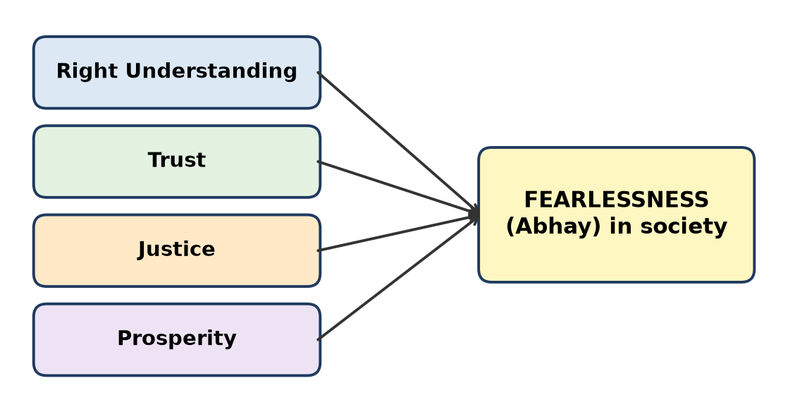
Figure: Inputs leading to fearlessness
1. Right Understanding - each person is clear about the purpose of life (mutual happiness) and needs. No confusion → no fear from within.
2. Trust - assurance that others intend my happiness as I intend theirs. Trust in intention removes suspicion.
3. Justice - values recognised and fulfilled in all relationships; fair treatment → no fear of exploitation or discrimination.
4. Prosperity - families feel they have more than needed → no fear of scarcity, no need to grab from others.
Why all four are needed:
- RU without prosperity → fear of survival may remain.
- Prosperity without trust → fear of theft, fraud.
- Trust without justice → trust breaks when wrong goes uncorrected.
- Justice without RU → only enforcement by fear of punishment.
Missing element | Fear that remains
RU | Confusion, insecurity within
Trust | Suspicion of others
Justice | Fear of exploitation
Prosperity | Fear of scarcity

Example: A housing society where members are clear, trust each other, settle disputes fairly and have enough lives without fear - doors can be left open.
Conclusion: Fearlessness cannot be imposed by laws alone; it grows from understanding, trust, justice and prosperity.
Remember: Clear minds + trusting hearts + fair dealings + enough at home = no fear.

Q29. Explain coexistence as a dimension of the human goal and relate it to sustainable living.
Difficult
Co-existence (Sah-astitva) is the human goal at the level of nature/existence: living in harmony and mutual fulfilment with all four orders - material, plant, animal and human.
Meaning:
1. Everything in existence is related; units exist together in space and fulfil each other.
2. The material, plant and animal orders are already in harmony; humans must join this harmony with Right Understanding.
3. Humans' role: enrich, protect and rightly utilise nature.
Relation to sustainable living:
1. Cyclicity - co-existence follows nature's cycles (water cycle, nutrient cycle); human production should also be cyclic.
2. Mutual fulfilment - take from nature and return to it (compost, afforestation, recycling).
3. Right quantity - use resources only as per need, allowing regeneration.
4. Respect for all life - protect biodiversity; animals and plants are not mere resources.
5. Long-term continuity - co-existence ensures resources for future generations.
Exploitation | Co-existence
Nature as resource | Nature as related
One-way taking | Mutual fulfilment
Waste and pollution | Recycling, restoration
Unsustainable | Sustainable

Figure: Mutual fulfilment among four orders
Example: Traditional sacred groves - communities protect forests, which in turn give water, herbs and climate balance.
Conclusion: Co-existence is the foundation of sustainability; living sustainably is simply living in co-existence.
Remember: Co-exist to continue to exist.

Q30. Explain how the five dimensions of human participation are interconnected, using the smart energy management system as an example.
Difficult
The five dimensions - Education–Sanskar, Health–Sanyam, Justice–Protection, Production–Work, Exchange–Storage - work together; failure in one affects all.
Smart energy management system (SEMS) - smart meters, sensors and software that monitor and optimise electricity use in homes, campuses or cities.
Dimension | Role in the SEMS example
Education–Sanskar | Engineers and users understand why energy must be saved; users develop the habit (sanskar) of responsible use
Health–Sanyam | Less pollution from power plants → better public health; users regulate their own consumption (self-regulation)
Justice–Protection | Fair billing, data privacy, protection from overcharging; equal access to energy; protection of nature
Production–Work | Design and manufacture of efficient meters, integration with solar/renewable sources; right work by engineers
Exchange–Storage | Battery storage of surplus solar power; selling extra to the grid (net metering) for mutual benefit

Interconnections:
1. Without education, users ignore the data → system fails.
2. Without justice (privacy, fair billing), people distrust it → no adoption.
3. Production of renewable energy needs storage and exchange to be reliable.
4. Saved energy reduces pollution → health improves.
5. Good health and trust encourage further education and participation - a cycle.
Figure: Five dimensions are interconnected
Conclusion: A technology succeeds sustainably only when all five dimensions support it.
Remember: One system, five dimensions, one harmony.

Q31. Explain the interconnectedness and mutual fulfillment among the Material, Plant/Bio, Animal and Human orders.
Difficult
All four orders are interconnected - each depends on and fulfils the others, maintaining cyclicity and balance in nature.
Figure: Interconnectedness of the four orders
Mutual fulfilment between orders:
Between | How they fulfil each other
Material ↔ Plant | Soil, water, minerals nourish plants; plants decay to form soil, prevent erosion
Material ↔ Animal | Water, air, minerals for animals; animal remains return to soil
Plant ↔ Animal | Plants give food, shelter, oxygen; animals give manure, pollination, seed dispersal
Material, Plant, Animal → Human | Metals, food, milk, fibre, energy, support in work
Human → all orders | Should enrich soil, plant trees, care for animals, recycle materials

Key points:
1. The first three orders are naturally in mutual fulfilment - no one exploits.
2. The human order is fulfilled by all, but often does not fulfil them - deforestation, pollution, cruelty.
3. Humans can be mutually fulfilling only with Right Understanding and right work (eco-friendly production).
4. Cyclicity: what is taken must be returned in a usable form.
Conclusion: Interconnectedness means harm to one order harms all, including humans; mutual fulfilment is the law of nature that humans must consciously follow.
Remember: Nature is a circle of giving; humans must complete the circle.

Q32. Differentiate between the exploitative approach and the holistic approach toward nature, and explain their consequences.
Difficult
Point | Exploitative approach | Holistic approach
View of nature | Resource to be used for profit | Related orders to live with
Basis | Desire, greed, competition | Right Understanding, mutual fulfilment
Use of resources | Unlimited, faster than regeneration | Need-based, within regeneration
Production | Linear: take → make → dump | Cyclic: need → produce → use → recycle → restore
Technology | Maximises output | People-friendly, eco-friendly
Relationship with other orders | Domination | Enrichment, protection, right use

Consequences of exploitative approach:
1. Resource depletion - fossil fuels, groundwater, forests.
2. Pollution - air, water, soil, plastic, e-waste.
3. Climate change and disasters - floods, droughts, heat waves.
4. Loss of biodiversity - extinction of species.
5. Social harm - displacement, health problems, inequality.
Consequences of holistic approach:
1. Sustainability - resources continue for future generations.
2. Health - clean air, water, food.
3. Prosperity - stable supply of needs.
4. Co-existence - harmony with all orders.
5. Fearlessness - no fight over scarce resources.
Example: Unplanned sand mining that destroys river beds (exploitative) vs. regulated harvesting with river restoration (holistic).
Conclusion: Exploitation gives short-term gain and long-term loss; the holistic approach gives lasting well-being for all.
Remember: Exploit = take and break; holistic = take, give back, keep.

Q33. Explain how a human being can either disturb the natural order or participate in mutual fulfillment.
Difficult
The human being is the only order with the freedom to choose. The material, plant and animal orders follow their nature (constitution, seed, breed), but humans act based on their understanding (or lack of it) - so they can either disturb or fulfil.
How humans disturb the natural order (without RU):
1. Over-consumption due to desire and greed.
2. Deforestation, mining, overfishing faster than regeneration.
3. Pollution - plastic, chemicals, emissions.
4. Cruelty to animals, destruction of habitats.
5. Linear production - waste that nature cannot absorb.
How humans participate in mutual fulfilment (with RU):
1. Enrichment - afforestation, organic farming, soil improvement.
2. Protection - conserving water bodies, wildlife, forests.
3. Right utilisation - using only what is needed, recycling.
4. Eco-friendly technology - renewable energy, biodegradable materials.
5. Education - spreading right understanding.
Without Right Understanding | With Right Understanding
Disturbs cycles | Joins cycles
Exploits | Enriches, protects
Short-term gain | Long-term harmony

Why the difference? Humans have the activity of knowing; their conduct is definite only when they understand. Education–Sanskar is therefore essential.
Conclusion: The same human hand can destroy or nurture; Right Understanding decides which.
Remember: Humans choose: be the problem or the partner of nature.

Q34. Explain how Individual → Family → Society → Nature → Existence represents an interconnected framework for holistic decision-making.
Difficult
Harmony exists at five levels, each inside the next. A decision at one level affects all others, so holistic decision-making checks all five.
Figure: Five levels of harmony
1. Individual - harmony in the Self and with the Body (RU, sanyam, health). Question: "Is this naturally acceptable to me? Does it keep me healthy and clear?"
2. Family - harmony in relationships; prosperity. Question: "Does it build trust and fulfil my family?"
3. Society - justice, fearlessness, universal human order. Question: "Is it fair to others? Does it build trust?"
4. Nature - mutual fulfilment with the four orders. Question: "Does it enrich or harm nature? Is it recyclable?"
5. Existence - co-existence of all units in space. Question: "Is it in harmony with the larger order?"
Example - choosing a career offer from a polluting factory with high pay:
Level | Check
Individual | Health risk, stress
Family | Good income but relocation
Society | Pollution affects local people
Nature | Water contamination
Existence | Disturbs natural cycles

A holistic decision may be to choose a slightly lower-paying job in a clean industry, or join and work to make the plant cleaner.
Conclusion: The framework turns decisions from "good for me" into "good for all" - which is ultimately good for me too.
Remember: Check every ring: me, family, society, nature, existence.

Q35. Explain the complete relationship among Four Human Goals → Five Dimensions → Four Orders → Mutual Fulfillment → Universal Harmony.
Difficult
This chain shows how individual understanding grows into universal harmony.
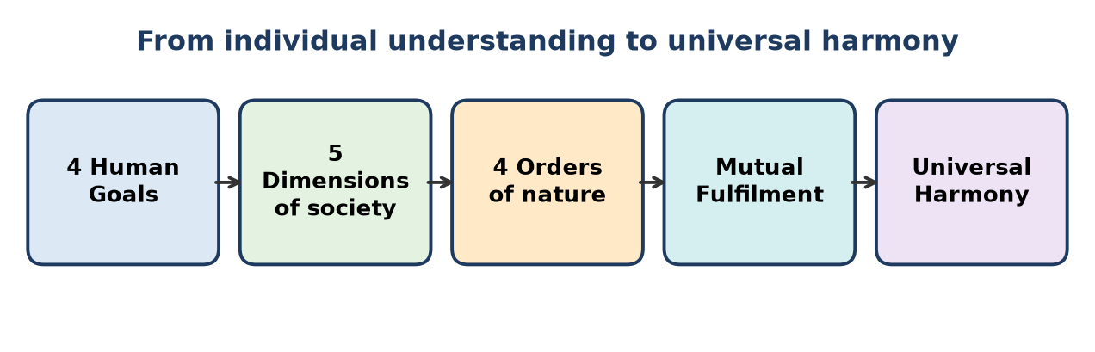
Figure: From human goals to universal harmony
1. Four Human Goals - Resolution (individual), Prosperity (family), Fearlessness (society), Co-existence (nature). These state what humanity wants.
2. Five Dimensions - Education–Sanskar, Health–Sanyam, Justice–Protection, Production–Work, Exchange–Storage. These are how society organises to achieve the goals.
- Education → resolution; Production + Exchange → prosperity; Justice → fearlessness; Health + all → co-existence.
3. Four Orders - Material, Plant, Animal, Human. The dimensions are carried out within nature, using and caring for all orders.
4. Mutual Fulfilment - when humans act through these dimensions with RU, they fulfil the other orders and are fulfilled by them (cyclicity, recyclability).
5. Universal Harmony - the result: harmony at all levels, from the individual to the whole existence - the Universal Human Order.
Stage | Answers
Human goals | What do we want?
Five dimensions | How do we organise?
Four orders | Where do we act?
Mutual fulfilment | How do we relate?
Universal harmony | What is the result?

Example: Education gives RU → families produce sustainably and exchange fairly → justice gives trust → nature is protected → harmony continues.
Conclusion: The chain is a complete model - from Self to existence - for sustainable and happy human living.
Remember: Goal → System → Nature → Fulfilment → Harmony.

Quick Revision – Unit 3
Term | Key fact
Knowledge (Gyan) | Understanding what is - Self, existence, conduct
Wisdom (Vivek) | Knowing purpose - what to do, why
Science (Vigyan) | Knowing how - methods, technology
Sustainable living | Harmony with four orders, cyclic, for all generations
Prosperity | Feeling of having more than required PF
Need vs greed | Limited, definite vs unlimited
Human goal | Resolution, Prosperity, Fearlessness, Co-existence
Levels of goal | Individual, family, society, nature
Five dimensions | Education–Sanskar, Health–Sanyam, Justice–Protection, Production–Work, Exchange–Storage
Four orders | Material, Plant/Bio, Animal, Human
Mutual fulfilment | Each order fulfils and is fulfilled by others
Consumer → contributor | From taking to participating
Human role | Right understanding, feeling, behaviour, work, participation
Technology | Neutral; purpose and use decide sustainability
Holistic vs GDP | Harmony and happiness vs output and consumption

Unit 4: Ethics

Q1. Explain the meaning of Ethics as Humane Conduct according to holistic understanding.
L2 – Understand
In holistic understanding (UHV / Madhyasth Darshan), ethics is humane conduct - the conduct that naturally comes from a human being who has Right Understanding. It is not a list of outside rules.
1. Humane conduct = definite human conduct - behaviour and work that are the same in all situations because they are based on understanding, not mood or fear.
2. Basis - right understanding of harmony in Self, family, society and nature.
3. Aim - mutual fulfilment with humans and with the rest of nature.
4. Components - Values (participation in the larger order), Policy (enrichment, protection, right utilisation) and Character (righteous wealth, marital loyalty, kindness in behaviour and work).
5. Naturally acceptable - every human being accepts it from within.
6. Universal - it applies to all people, places and times.
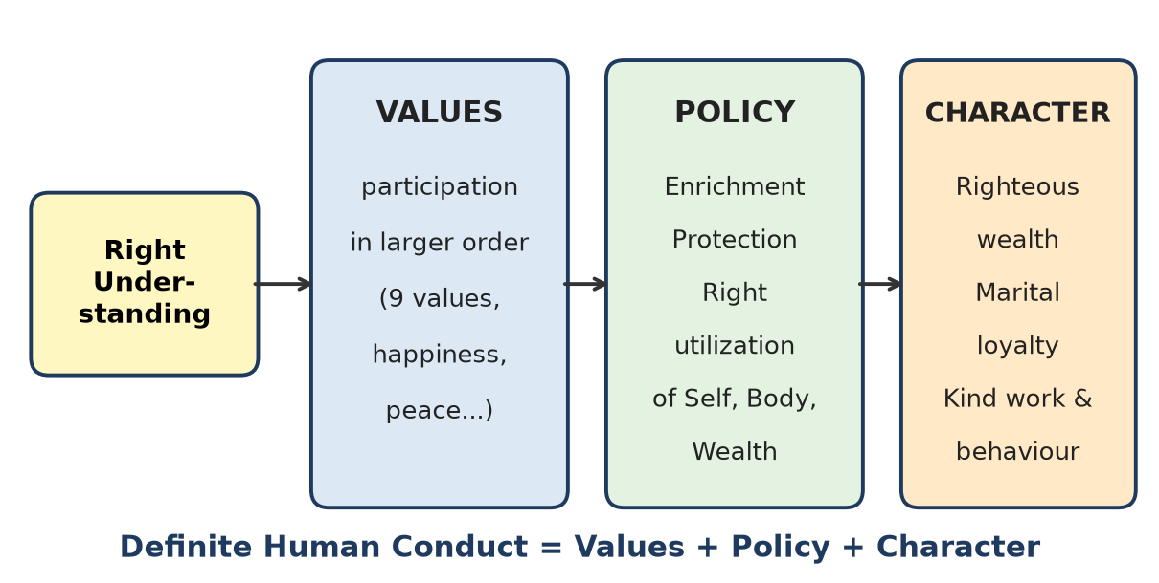
Figure: Definite human conduct
Remember: Ethics is not imposed; it is how an understanding human naturally behaves.

Q2. Explain the need for ethics in the context of scientific and technological advancement.
L2 – Understand
Science and technology answer "how to do"; ethics answers "what should be done and why". As technology becomes more powerful, the need for ethics grows.
1. Greater power, greater harm - nuclear weapons, chemical pollution, AI misuse, genetic engineering can affect millions.
2. Environmental crisis - unchecked technology has caused climate change, resource depletion and e-waste.
3. Social effects - automation and surveillance raise questions of jobs, privacy and fairness.
4. Purpose missing - technology without wisdom serves greed and consumption, not human welfare.
5. Speed of change - laws lag behind; engineers' own ethics must guide them.
6. Trust - people trust technology only when it is honest and safe.
Without ethics | With ethics
Profit and power first | Human welfare first
Exploitation of nature | Eco-friendly design
Misuse of data | Privacy and fairness

Remember: Science gives the engine; ethics gives the steering.

Q3. Describe the relationship between right understanding and ethical conduct.
L2 – Understand
Right Understanding (RU) is understanding the harmony in Self, family, society and nature. Ethical conduct is behaviour and work that leads to mutual fulfilment. RU is the cause; ethical conduct is the effect.
1. RU gives clarity about what is right - mutual happiness and prosperity.
2. RU gives right feelings - trust, respect, affection - which show in behaviour with people.
3. RU gives right purpose in work - production that enriches nature.
4. RU makes conduct definite - not changing with fear, greed or pressure.
5. RU makes ethics self-driven - no outside control needed.
6. Without RU, ethics is only rule-following and breaks easily under temptation.
Figure: Self-exploration to conduct
Example: An engineer who understands that safety of users is part of her own happiness will not hide defects, even if no one is checking.
Remember: Understand rightly → feel rightly → act rightly.

Q4. Explain why rules, regulations and punishment alone are insufficient to ensure ethical conduct.
L2 – Understand
Rules and punishment are external controls. They help, but cannot by themselves create ethical conduct.
1. Fear-based - people follow rules only out of fear; when unobserved, they may break them.
2. Loopholes - clever people find ways around rules.
3. Cannot cover every situation - new technologies and situations arise faster than laws.
4. No inner change - the person's understanding and desires remain the same.
5. Costly - more policing, auditing and courts are needed.
6. Breaks trust - a system based on suspicion reduces mutual trust.
7. Rules depend on the rule-makers - if they lack understanding, rules can be unjust.
External control | Right Understanding
Fear of punishment | Natural acceptance
Works when watched | Works always
Temporary | Lasting

Rules are needed as a support, but the real source of ethics is Right Understanding developed through education and self-exploration.
Remember: Rules control hands; understanding guides hearts.

Q5. Explain the meaning of harmony and co-existence at the levels of the individual, family, society, nature and existence.
L2 – Understand
Harmony = being in a state of balance and mutual fulfilment; co-existence = being together in a related way.
Figure: Five levels of harmony
Level | Harmony means | Outcome
Individual | Harmony in the Self (clear desires, thoughts, expectations) and between Self and Body (sanyam, swasthya) | Resolution, health
Family | Values fulfilled in relationships; physical facility more than needed | Mutual happiness, prosperity
Society | Justice, trust; five dimensions working well | Fearlessness, universal human order
Nature | Four orders in mutual fulfilment and cyclicity | Co-existence, sustainability
Existence | All units co-existing in space, each fulfilling its role | Universal harmony

Each level contains the earlier ones; harmony at the individual level is the starting point for all.
Remember: Harmony begins in me and spreads to existence.

Q6. Explain the concept of Natural Acceptance and describe its characteristics.
L2 – Understand
Natural Acceptance is the basic, inner "yes" of a human being to what is right - for example, every human naturally accepts trust over doubt, respect over disrespect, mutual happiness over exploitation. It is the inner reference for self-exploration.
Characteristics:
1. Innate - present in every human being from within; not taught from outside.
2. Invariant - does not change with time; what is acceptable today remains so.
3. Universal - same for all humans, across cultures and places.
4. Independent of beliefs - not based on pre-conditioning, habits or sensation.
5. Always there - may be ignored but never lost.
6. Points to mutual fulfilment - naturally accepts what is good for self and others together.
7. Definite - gives a clear answer when asked honestly.
Example: Ask yourself, "Do I want to be respected or disrespected?" The answer is always "respected" - for everyone. That is natural acceptance.
Remember: Natural acceptance is the inner compass that never changes.

Q7. Differentiate between Natural Acceptance and temporary liking arising from sensation, habit, fear, greed or social conditioning.
L2 – Understand
Point | Natural Acceptance | Temporary liking
Source | Within the Self, innate | Sensation, habit, fear, greed, social conditioning
Time | Invariant, does not change | Changes with mood, age, fashion
People | Universal - same for all | Differs from person to person
Basis | Mutual fulfilment | Personal pleasure or comfort
Result | Lasting happiness, harmony | Short pleasure, later conflict or regret
Example | Accepting honesty | Liking to copy in exam out of fear

Sources of temporary liking:
- Sensation - liking junk food for taste.
- Habit - liking late-night scrolling.
- Fear - agreeing with the boss to stay safe.
- Greed - liking a shortcut that gives more money.
- Social conditioning - liking a brand because "everyone has it".
How to check: Ask whether the liking is the same at all times, for all people and leads to mutual happiness - if not, it is temporary liking.
Remember: Likings change; natural acceptance stays.

Q8. Explain the difference between External Control and Self-exploration in developing ethical conduct.
L2 – Understand
External control makes people behave through rules, rewards, fear of punishment and supervision. Self-exploration develops ethics from within, by verifying what is right on one's own natural acceptance.
Point | External control | Self-exploration
Source | Outside authority | Inside the Self
Motivation | Fear or reward | Understanding
Consistency | Only when watched | Always
Change in person | Behaviour changes, mind does not | Understanding and behaviour both change
Effect on trust | Builds suspicion | Builds trust
Durability | Temporary | Lasting
Example | Not cheating because of CCTV | Not cheating because honesty is naturally acceptable

Process of self-exploration: take a proposal → verify on natural acceptance → test in living (behaviour with humans, work with nature) → understanding → definite conduct.
External control is useful as a support in society, but self-exploration is the foundation of lasting ethics.
Remember: Control from outside is a fence; self-exploration is a compass.

Q9. Describe how self-exploration leads from Natural Acceptance to Understanding, Resolution and Conduct.
L2 – Understand
Self-exploration is the process of looking within to find what is right, using natural acceptance as the reference and experience as the test.
Figure: Self-exploration process
1. Proposal - a statement or question is taken (e.g., "Happiness comes from harmony").
2. Natural Acceptance - check: "Is this naturally acceptable to me?" without being driven by beliefs or sensation.
3. Experiential validation - test it in living: behaviour with humans gives mutual happiness? work with nature gives mutual prosperity?
4. Understanding (realisation) - when verified both ways, it becomes my own understanding, not borrowed knowledge.
5. Resolution (Samadhan) - contradictions in desires, thoughts and expectations disappear; there is clarity.
6. Conduct - clear understanding naturally shows as definite human conduct in behaviour, work and participation.
Example: A student checks "Is cheating right?" Natural acceptance says no; experience shows it brings guilt and broken trust; understanding forms; he stays honest in every exam.
Remember: Accept inside, test outside, live it always.

Q10. Explain the relationship between self-awareness, self-evaluation and Right Understanding.
L2 – Understand
1. Self-awareness - being aware of what is going on in the Self: my desires, thoughts, expectations and feelings, and their sources (sensation, pre-conditioning or natural acceptance).
2. Self-evaluation - checking these against natural acceptance: "Is this desire right? Is my behaviour leading to mutual happiness?"
3. Right Understanding - the result of honest self-evaluation over time: clear knowledge of harmony in Self and existence.
Relationship (a chain):
- Awareness → Evaluation → Understanding.
- Without awareness, I do not even notice wrong assumptions.
- Without evaluation, awareness stays as observation without correction.
- Understanding then improves awareness further - a cycle of growth.
Step | Question asked
Self-awareness | What am I thinking/feeling?
Self-evaluation | Is it naturally acceptable?
Right Understanding | What is truly right?

Example: I notice I am angry at a friend (awareness); I see that the anger is from my expectation, not the friend's intention (evaluation); I understand trust in intention (RU).
Remember: Notice → check → understand.

Q11. Explain the meaning of Responsibility and distinguish it from an externally assigned duty.
L2 – Understand
Responsibility is the feeling from within to fulfil my role in a relationship, arising naturally from recognising the relationship and having right feelings (trust, care, affection). Duty (externally assigned) is a task given by someone else - by rules, contract or authority - that I must do.
Point | Responsibility | Externally assigned duty
Source | Inner feeling, Right Understanding | Outside rule, boss, law
Motivation | Care, relationship | Obligation, fear, reward
Feeling while doing | Joy, fulfilment | Burden, pressure
Consistency | Continues even unobserved | May stop when unchecked
Scope | Goes beyond the minimum | Limited to what is assigned
Example | Caring for ill parents out of affection | Filing a report because the manager ordered it

Key point: The same task (e.g., teaching) can be a burden as duty or a joy as responsibility; the difference is understanding and feeling.
Remember: Duty is given; responsibility is felt.

Q12. Describe the relationship between Recognition, Trust, Responsibility, Participation and Mutual Fulfilment.
L2 – Understand
These five form a natural sequence in human relationships and society.
1. Recognition - recognising the relationship and its values ("this person is related to me; we both want happiness").
2. Trust - from recognition comes the assurance that the other intends my good as I intend theirs - the foundation value.
3. Responsibility - when I trust and feel related, I naturally feel responsible for fulfilling my part.
4. Participation - responsibility shows as active taking part - in family, work, society, nature (the five dimensions).
5. Mutual Fulfilment - participation by all leads to happiness and prosperity for all - ubhay-tripti.
Recognition → Trust → Responsibility → Participation → Mutual Fulfilment
Example - team project: Members recognise they share a goal → trust each other's intention → each takes responsibility for a part → all participate fully → project succeeds and everyone feels fulfilled.
If recognition is missing, the chain breaks: no trust, only blame and minimum effort.
Remember: Recognise, trust, own, act - all are fulfilled.

Q13. Explain the meaning of Gender Equality in Dignity and the statement "Difference in Role does not mean Difference in Dignity."
L2 – Understand
Gender Equality in Dignity means that men and women are equal as human beings - in the Self ('I') they have the same aspiration (continuous happiness), the same activities and the same potential for understanding. Differences are only at the level of the Body.
"Difference in Role does not mean Difference in Dignity":
1. In family, work or society, people may take different roles based on ability, interest, situation or body.
2. These roles are complementary, not higher or lower.
3. Dignity (worth) belongs to the Self, so it is equal for all, whatever the role.
4. Valuing one role (earning) above another (caring for home) is wrong evaluation.
5. Judging by body (gender) is a form of disrespect (otherwise evaluation).
Wrong view | Right view
Role decides worth | Worth is equal; roles differ
Based on body | Based on Self
Domination | Mutual respect

Example: A homemaker and a working spouse both contribute to the family; both deserve equal respect and voice in decisions.
Remember: Roles may differ; respect must not.

Q14. Explain the importance of equal human dignity in family, educational institutions and professional life.
L2 – Understand
Equal human dignity = every person is equally worthy of respect, because all are equal in the Self.
In family:
1. Equal respect for husband and wife, sons and daughters, elders and young.
2. Shared decisions and responsibilities.
3. Children learn equality by example → healthy future society.
In educational institutions:
1. Every student respected regardless of marks, gender, caste, economic status.
2. Teachers guide weak students without labelling them.
3. Builds confidence, cooperation and a safe learning environment.
In professional life:
1. Fair pay, opportunity and promotion for all.
2. Respect for every role - from cleaner to CEO.
3. No harassment or discrimination; better teamwork and trust.
Overall importance:
- Builds trust and justice.
- Reduces conflict, fear and inequality.
- Leads to mutual happiness and fearlessness in society.
Without equal dignity | With equal dignity
Discrimination, fear | Trust, cooperation
Talent wasted | Talent flourishes

Remember: Equal dignity is the ground on which trust grows.

Q15. Explain the meaning of Definite Human Conduct and its relationship with Right Understanding.
L2 – Understand
Definite Human Conduct is the conduct of a human being that is certain, consistent and universal - it does not change with time, place or person - and leads to mutual fulfilment. It is expressed as values, policy and character.
Why "definite": Animal conduct is fixed by breed; human conduct is not fixed by body. It becomes definite only through Right Understanding. Without RU, human conduct is indefinite - changing with desire, fear and conditioning.
Relationship with RU:
1. RU is the source - understanding of harmony gives clarity on what is right.
2. RU gives right feelings → right behaviour with people.
3. RU gives right purpose → right work with nature.
4. RU gives resolution → conduct does not vary under pressure.
5. RU makes it universal - the same for all understanding humans.
Without RU | With RU
Indefinite conduct | Definite conduct
Changes with situation | Same in all situations
Self-centred | Mutually fulfilling

Figure: Definite human conduct = values + policy + character
Remember: Understanding makes conduct definite; confusion makes it random.

Q16. Explain the three dimensions of ethical living: Values, Character and Work Ethics.
L2 – Understand
1. Values
- Values are a human being's participation in the larger order - in relationships (trust, respect, affection, care, guidance, reverence, glory, gratitude, love) and with nature.
- They arise naturally from Right Understanding.
- Example: trust in a friend, respect for every colleague.
2. Character
- The way values show in personal life: righteous wealth (earning by right means), loyalty in marital relationship, and kindness/compassion in behaviour and work.
- Character makes a person reliable in all situations.
- Example: refusing a bribe, being faithful to one's spouse.
3. Work Ethics
- Values applied in profession - honesty, diligence, competence, responsibility, fairness, care for users and nature.
- Work is seen as participation and contribution, not just earning.
- Example: an engineer testing a product thoroughly before release.
Dimension | Area of life | Key feature
Values | Relationships, larger order | Participation
Character | Personal conduct | Integrity
Work ethics | Profession | Responsible contribution

Remember: Values inside, character in life, ethics at work.

Q17. Explain the relationship among Values, Policy and Character.
L2 – Understand
Definite human conduct has three parts that flow from Right Understanding.
Figure: Values, Policy and Character
1. Values (Mulya) - participation of a human in the larger order; feelings like trust, respect, love; the inner basis.
2. Policy (Niti) - decisions and plans for enrichment, protection and right utilisation of resources - the Self, the Body and physical facility (wealth). Policy puts values into plans for society.
3. Character (Charitra) - the visible conduct of a person: righteous wealth, loyalty in marital relationship, kindness in behaviour and work.
Relationship:
- Values → Policy: values decide what policies are right (e.g., care for nature → policy of protection).
- Policy → Character: following right policy in life shapes character (right utilisation of wealth → righteous wealth).
- Character reflects values: good character is values in action.
- All three are needed: values without policy stay as ideas; policy without values becomes manipulation; character without values becomes show.
Remember: Values feel, policy plans, character lives.

Q18. Describe the role of trust, respect, affection, care, guidance, reverence, gratitude and love in human relationships.
L2 – Understand
Value | Meaning | Role in relationship
Trust (vishwas) | Assurance that the other intends my happiness | Foundation; removes fear and doubt
Respect (samman) | Right evaluation - other is like me | Removes comparison, ego
Affection (sneh) | Feeling of being related | Brings closeness, acceptance
Care (mamta) | Responsibility to nurture and protect the body of relative | Physical support, health
Guidance (vatsalya) | Responsibility for right understanding of relative | Growth of the Self
Reverence (shraddha) | Acceptance of excellence in the other | Inspires one to grow
Gratitude (kritagyata) | Feeling for those who helped my excellence | Strengthens bonds, humility
Love (prem) | Feeling of being related to all | Complete value; universal relationship

(The ninth value is glory (gaurav) - feeling for those who work for others' excellence.)
Overall role: these values, when recognised and fulfilled, ensure justice and lead to mutual happiness. Trust is the base; love is the completion.
Figure: Nine values in relationship
Remember: Trust starts it, love completes it.

Q19. Explain the meaning of Value as Participation in the Larger Order, distinguishing it from monetary price.
L2 – Understand
Value (in UHV) is the participation of a unit in the larger order of which it is a part. Every unit has a role in a bigger system, and fulfilling that role is its value.
Examples:
- Pen - its value is its participation in writing (larger order: human activity of expression).
- Tree - gives oxygen, fruits, soil protection - participation in nature.
- Human being - value is participation in the human order - right understanding, right feelings, right behaviour and right work.
Monetary price is the money for which a thing is exchanged in the market; it depends on demand, supply, branding and bargaining.
Value | Monetary price
Participation in the larger order | Exchange amount in market
Intrinsic, definite | Variable, changes with market
Same everywhere | Differs by place and time
Applies to humans and relationships | Mainly to goods and services
Example: value of water = life | Price of bottled water = ₹20

Key point: Things of highest value (air, water, trust, love) often have little or no price. Confusing price with value leads to exploitation of nature and relationships.
Remember: Price is what you pay; value is what it contributes.

Q20. Explain the values associated with the Self and human-human relationships according to the presentation.
L2 – Understand
A. Values associated with the Self ('I') - experienced within when there is harmony:
1. Happiness (sukh) - harmony in the Self.
2. Peace (shanti) - harmony in thoughts (analysis).
3. Satisfaction (santosh) - harmony in desires.
4. Bliss (anand) - harmony with the whole existence.
Natural characteristics of a human being also include perseverance, bravery and generosity.
B. Values in human-human relationships - the nine established values:
Value | Feeling
Trust | Other wants my happiness
Respect | Right evaluation
Affection | Being related
Care | Nurture and protect body
Guidance | Ensure right understanding
Reverence | Accept excellence
Glory | For those working for others' excellence
Gratitude | For those who helped my excellence
Love | Related to all - complete value

These values are expressed in behaviour as gentleness, courtesy, simplicity and humility.
Relation: values in the Self (happiness, peace) flow out as values in relationships; fulfilling relationship values brings mutual happiness back into the Self.
Remember: Inside: happiness, peace, satisfaction, bliss. Outside: nine values.

Q21. Explain the three policies of Enrichment, Protection and Right Utilization of the Self, Body and Physical Facility.
L2 – Understand
Policy (Niti) in human conduct means deciding how to deal with our three resources - Self, Body and Physical Facility (wealth) - through enrichment, protection and right utilisation.
Resource | Enrichment | Protection | Right utilisation
Self ('I') | Develop right understanding and feelings through education and self-exploration | Protect from wrong assumptions, fear, greed | Use understanding for mutual fulfilment
Body | Nourish with proper food, exercise, rest (sanyam) | Protect from illness, injury, addictions | Use the body as an instrument for right work and behaviour
Physical facility | Produce more than needed through right work (prosperity) | Preserve, maintain, store properly; no waste | Use for need of self, family and society; share surplus

Importance:
1. Ensures prosperity without exploitation.
2. Keeps the body healthy (swasthya).
3. Keeps the Self resolved.
4. Forms the basis for universal human order - economic, political and social policies follow these three principles.
Remember: Enrich, protect, use rightly - for Self, Body and wealth.

Q22. Explain the meaning of Right Work and its relationship with mutual enrichment and eco-friendly production.
L2 – Understand
Right Work is the human activity of producing physical facilities with the rest of nature in a way that leads to mutual enrichment - humans get their needs and nature is enriched, not harmed.
Features of right work:
1. Based on identified needs, not greed.
2. Uses resources in the right quantity within regeneration limits.
3. Follows cyclicity - waste returns to nature in usable form.
4. People-friendly - safe, uses human skills, gives dignity.
5. Seen as participation and contribution, not just earning.
Relationship with mutual enrichment:
- Right work enriches both - e.g., organic farming gives food and improves soil.
- Wrong work enriches humans in the short term but depletes nature - e.g., chemical-heavy farming.
Relationship with eco-friendly production:
- Eco-friendly production is right work in practice: renewable energy, recyclable materials, low pollution, local resources.
Right work | Wrong work
Need-based | Greed-based
Cyclic, recyclable | Linear, wasteful
Enriches nature | Depletes nature

Remember: Right work takes from nature and gives back more.

Q23. Describe the sequence Need → Production → Right Acquisition → Utilization → Preservation → Prosperity in the context of Right Wealth.
L2 – Understand
Right wealth is wealth that is produced and acquired by right means and used for mutual fulfilment. It follows a clear sequence:
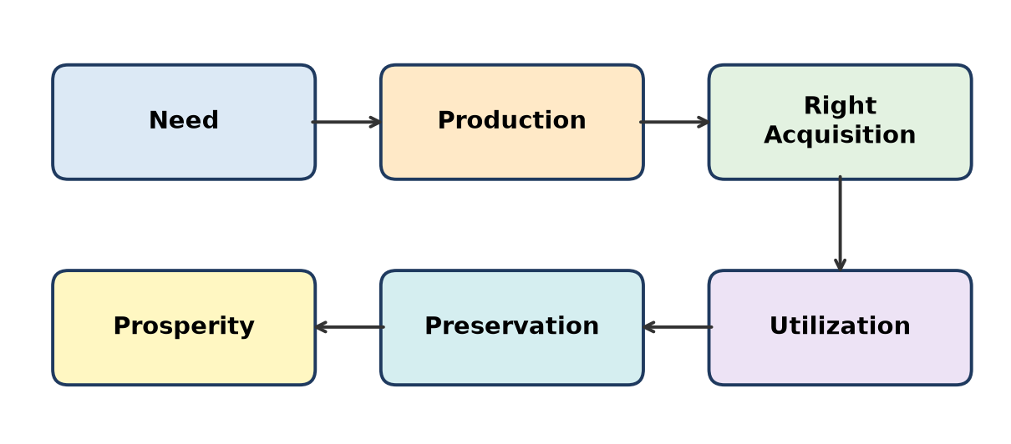
Figure: Right wealth sequence
1. Need - identify the real need of Body, family and society with Right Understanding.
2. Production - produce physical facilities through right work, eco-friendly and people-friendly.
3. Right Acquisition - obtain wealth by just means - own labour, fair exchange; no cheating, bribery, exploitation.
4. Utilization - use the wealth for real needs of self, family and society; no wasteful display.
5. Preservation - maintain, protect and store properly; avoid waste and hoarding.
6. Prosperity - the feeling of having more than needed; surplus is shared.
Importance:
- Prevents greed, corruption and exploitation.
- Makes wealth a source of happiness, not fear.
- Supports sustainability - production matches need.
Example: A craftsman makes quality furniture (production), sells at a fair price (right acquisition), spends on family education (utilisation), saves for the future (preservation) and feels prosperous.
Remember: Need it, make it, earn it fairly, use it, save it - feel prosperous.

Q24. Explain the meaning of Right Marital Relationship in terms of recognition, trust, respect, responsibility and mutual fulfilment.
L2 – Understand
Right marital relationship is the relationship between husband and wife based on Right Understanding, with commitment to each other's growth and happiness and to building a family with values.
1. Recognition - both recognise the relationship: "we are partners for mutual fulfilment and for continuing the human tradition through our family".
2. Trust - each is assured that the other intends their happiness; trust in intention even when competence differs.
3. Respect - right evaluation; both are equal in dignity; roles differ, worth does not.
4. Responsibility - each takes responsibility for the other's well-being, for children, for parents, for the household; loyalty is part of this.
5. Mutual fulfilment - both feel happy and complete; children grow in a harmonious environment (ubhay-tripti).
Element | Shown as
Recognition | Commitment
Trust | No suspicion, openness
Respect | Equal voice in decisions
Responsibility | Shared duties, loyalty
Mutual fulfilment | Happiness, healthy family

Remember: Recognise, trust, respect, share - both are fulfilled.

Q25. Explain the concepts of Righteous Wealth, Loyalty in Marital Relationship, Compassionate Work and Behavior in the context of ethical living.
L2 – Understand
These three together form Character (Charitra) - the personal part of definite human conduct.
1. Righteous Wealth (Svadhan)
- Wealth earned through one's own right work and fair exchange - no theft, bribery, cheating or exploitation.
- It gives peace and prosperity; ill-gotten wealth brings fear.
- Example: salary earned honestly; fair profit in business.
2. Loyalty in Marital Relationship
- Faithfulness and commitment to one's own spouse (one husband - one wife).
- Builds trust and security in family; protects children's growth.
- Example: no deceit or extra-marital relationship.
3. Compassionate (Kind) Work and Behaviour (Dayapurna karya-vyavahar)
- Behaviour with humans based on kindness, respect, care.
- Work with nature based on compassion - no cruelty, no wasteful destruction.
- Example: treating workers fairly; designing products that do not harm animals or environment.
Character element | Area | Result
Righteous wealth | Economic life | Prosperity without fear
Marital loyalty | Family life | Trust, stable family
Compassionate work and behaviour | Society and nature | Justice, co-existence

Remember: Clean money, faithful marriage, kind conduct = good character.

Q26. Explain the significance of Non-accumulation, Affection, Simplicity, Right Knowledge, and Fearlessness in human relationships and social order.
L2 – Understand
1. Non-accumulation - not gathering wealth beyond need. Removes greed and hoarding; surplus reaches others; reduces inequality and exploitation; supports prosperity for all.
2. Affection - feeling of being related to others. Brings closeness and acceptance; reduces conflict; makes people help each other.
3. Simplicity - living with natural, uncomplicated needs and straightforward behaviour. Less consumption, less stress, less show; honest communication builds trust.
4. Right Knowledge - right understanding of Self, existence and human conduct. Gives clarity and definite conduct; removes confusion and wrong assumptions.
5. Fearlessness - freedom from fear, arising from trust and justice. People act honestly and cooperate; no need for domination or defence.
Quality | In relationships | In social order
Non-accumulation | No jealousy | Fair distribution
Affection | Closeness | Cooperation
Simplicity | Openness | Low consumption
Right knowledge | Clarity, trust | Definite conduct
Fearlessness | Honesty | Peace, justice

Together they create a society of trust and sharing - the base of the universal human order.
Remember: Take less, relate more, live simply, know rightly, fear nothing.

Q27. Explain the principles of natural cyclicality, complementarity in balance and expenditure in proportion in relation to nature.
L2 – Understand
1. Natural cyclicality
- Nature works in cycles - water cycle, carbon cycle, nutrient cycle, life cycle of plants and animals.
- Nothing is waste; output of one becomes input of another.
- Human principle: production should also be cyclic and recyclable.
2. Complementarity in balance
- The four orders complement each other - each fulfils the others and keeps the system balanced (plants give oxygen, animals give CO2 and manure).
- No order exploits another; balance is maintained naturally.
- Human principle: our activities must support, not disturb, this balance.
3. Expenditure in proportion
- Nature uses resources in proportion to regeneration - a forest grows only as much as soil, water and sunlight allow.
- Human principle: use resources only to the extent they can be replenished; consumption in proportion to need and nature's capacity.
Principle | Nature shows | Humans should
Cyclicality | No waste | Recycle, compost
Complementarity | Mutual fulfilment | Enrich and protect
Proportion | Use = regeneration | Use within limits

Figure: Cyclic production
Remember: Nature recycles, balances and budgets - so should we.

Q28. Explain how harmony at the individual and family levels contributes to justice, fearlessness and Universal Human Order.
L2 – Understand
1. Harmony at individual level
- Right understanding → resolution; harmony between Self and Body → health.
- Such a person has clear values, definite conduct and no need to exploit.
2. Harmony at family level
- Values (trust, respect, affection) fulfilled → justice in the family.
- Needs identified and fulfilled → prosperity.
- Children learn values by example.
How it extends to society:
1. Justice - people who live justice at home carry it to workplace and society; family is the first school of justice.
2. Fearlessness - resolved, prosperous families trust others and are trusted → fear reduces in society.
3. Universal Human Order - families join to form a family cluster, villages and the world family; the five dimensions run smoothly when individuals and families are in harmony.
Level | Harmony gives | Contribution to society
Individual | Resolution, health | Definite conduct
Family | Justice, prosperity | Trust, fearlessness
Society | - | Universal Human Order

Figure: Harmony from individual to existence
Remember: Harmony in me → harmony at home → harmony in the world.

Q29. Explain the difference between technical competence, expressed through "Can I do it?", and professional ethics, expressed through "Should I do it?".
L2 – Understand
Technical competence is the skill and knowledge to do a task - "Can I do it?". Professional ethics is the judgement about whether the task is right and leads to human welfare - "Should I do it?".
Point | Technical competence | Professional ethics
Question | Can I do it? | Should I do it?
Based on | Skills, training, tools | Right Understanding, values
Concerned with | How | Why and whether
Measures | Efficiency, quality | Welfare, safety, fairness, sustainability
Without the other | Skill may serve harm | Good intent may fail without skill
Example | Can I write code to track users secretly? | Should I invade users' privacy?

Key points:
1. Competence without ethics can be dangerous - a skilled hacker, a bridge built with cheap material.
2. Ethics without competence can be ineffective - good intention but faulty product.
3. A true professional has both: ability to do and wisdom to choose.
4. UHV calls this competence in professional ethics - using professional skill with definite human conduct.
Remember: "Can I?" tests skill; "Should I?" tests character.

Q30. Explain the responsibilities of an engineer toward the Self, Users, Organization, Society and Nature.
L2 – Understand
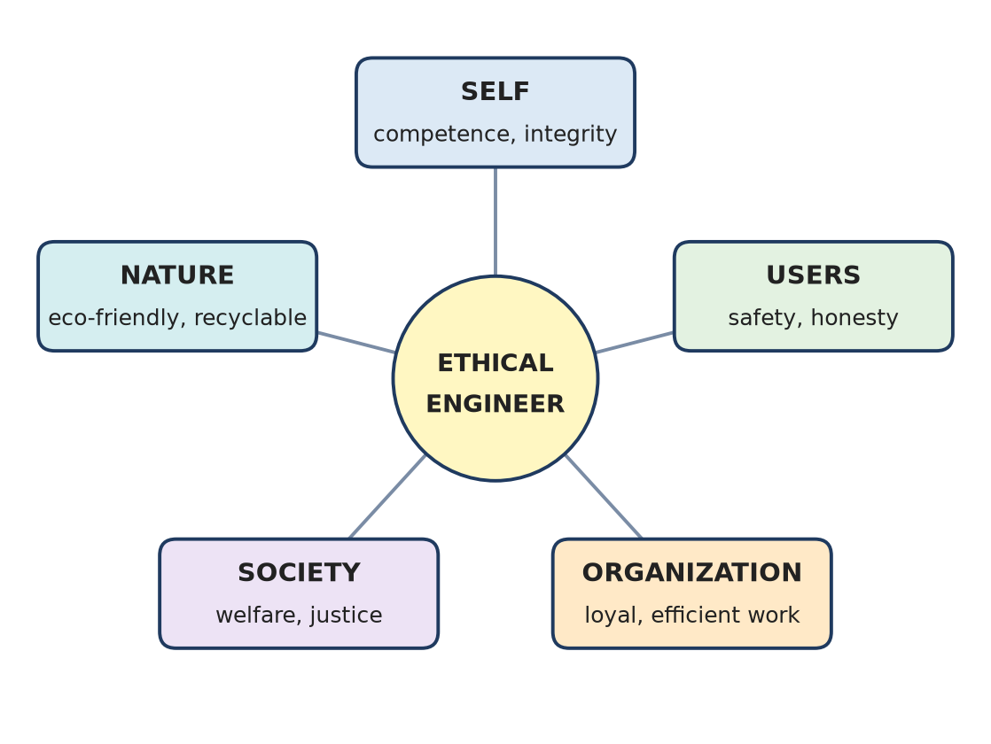
Figure: Engineer's responsibilities
1. Toward the Self
- Keep developing competence and right understanding.
- Maintain integrity; take care of own health (sanyam).
2. Toward Users
- Ensure safety, quality and reliability of products.
- Be honest about limitations; protect user data and privacy.
3. Toward the Organization
- Work sincerely and efficiently; loyalty within ethical limits.
- Protect confidential information; avoid conflicts of interest; report wrongdoing responsibly.
4. Toward Society
- Work for public welfare; avoid harm, discrimination and exploitation.
- Make technology affordable and accessible; follow laws and standards.
5. Toward Nature
- Design eco-friendly, energy-efficient, recyclable products.
- Minimise waste and pollution; use renewable resources.
Toward | Key responsibility
Self | Competence, integrity
Users | Safety, honesty
Organization | Sincere, loyal work
Society | Welfare, justice
Nature | Sustainability

Remember: An engineer serves five masters: self, user, employer, society, nature.

Q31. Describe the characteristics of people-friendly and eco-friendly technology.
L2 – Understand
Holistic technology is both people-friendly and eco-friendly.
People-friendly technology:
1. Safe and healthy for users and workers.
2. Easy to use, understand and maintain locally.
3. Affordable and accessible to all, not only the rich.
4. Uses human skills and gives dignified work; does not make people redundant without alternatives.
5. Supports decentralised, small-scale production where suitable.
6. Fulfils real needs, not artificial wants.
Eco-friendly technology:
1. Uses renewable and local resources.
2. Energy-efficient; low emissions.
3. Products are recyclable or biodegradable.
4. Follows natural cycles; minimal waste.
5. Does not harm plants, animals, soil, water or air.
6. Durable and repairable.
People-friendly | Eco-friendly
Safe, affordable | Renewable, low-pollution
Uses local skills | Uses local resources
Meets real needs | Recyclable, cyclic

Examples: solar lamps, biogas plants, drip irrigation, rainwater harvesting.
Remember: Good for people, good for the planet.

Q32. Explain the technical and ethical considerations involved in designing a smart energy meter.
L2 – Understand
A smart energy meter measures electricity use in real time and communicates data to the user and utility for billing and energy management.
Technical considerations:
1. Accuracy of measurement and billing.
2. Reliability - works in heat, dust, voltage fluctuations; long life.
3. Communication - secure data transfer (GSM/RF/PLC).
4. Low power consumption of the meter itself.
5. Integration with solar/renewable sources and net metering.
6. Cost-effective, maintainable design.
Ethical considerations:
1. Data privacy - usage data can reveal daily habits; must be encrypted and used only with consent.
2. Fair billing - no hidden charges or manipulation; transparent display.
3. Accessibility - simple interface for all, including elderly and less literate users.
4. No unfair disconnection - especially for poor households; humane policies.
5. Environmental - recyclable components, low e-waste, encourages energy saving.
6. Honesty - true claims about savings.
Technical | Ethical
Accuracy, reliability | Fairness, honesty
Secure communication | Privacy, consent
Low cost | Affordable, accessible
Renewable integration | Sustainability

Remember: Measure power accurately; use data responsibly.

Q33. Explain how relationship, cooperation, justice and shared responsibility contribute to humanistic management.
L2 – Understand
Humanistic management treats an organisation as a family of human beings working together for mutual fulfilment - of employees, customers, society and nature - not just for profit.
1. Relationship - managers and employees see each other as related; trust and respect replace command-and-control. Result: open communication, loyalty, low attrition.
2. Cooperation - teams cooperate instead of competing internally; knowledge is shared. Result: better innovation and efficiency.
3. Justice - fair pay, fair evaluation, equal opportunity, no discrimination; values recognised and fulfilled. Result: trust and motivation.
4. Shared responsibility - everyone feels ownership of goals; decisions are participative. Result: commitment, quality, fewer failures.
Conventional management | Humanistic management
Profit maximisation | Mutual fulfilment
Employees as resources | Employees as humans
Control and fear | Trust and responsibility
Internal competition | Cooperation

Outcome: a productive, ethical organisation where people are happy, customers are served honestly and nature is respected.
Remember: Manage people as relations, not resources.

Q34. Explain how professional ethics connects technical competence with human welfare, mutual fulfilment and harmony with nature.
L2 – Understand
Professional ethics is the use of professional competence with definite human conduct - it acts as the bridge between skill and human welfare.
1. Competence alone is power without direction; it may serve greed, harm users or damage nature.
2. Ethics gives direction - asks "Should I do it?" and "Is it good for all?"
How professional ethics connects:
1. With human welfare - ensures safety, quality, honesty, privacy, affordability; products fulfil real needs.
2. With mutual fulfilment - fair dealings with users, employers, colleagues and suppliers; everyone benefits (no exploitation).
3. With harmony with nature - eco-friendly design, renewable resources, recyclability, minimal waste.
Competence in professional ethics (UHV) includes the ability to:
- Identify and develop holistic (people-friendly, eco-friendly) technologies.
- Design holistic production systems.
- Practise humanistic management models.
Technical competence + Professional ethics → Human welfare + Mutual fulfilment + Harmony with nature
Competence only | Competence + ethics
Efficient but risky | Efficient and safe
Profit-focused | Welfare-focused
Harms nature | Sustains nature

Remember: Skill builds things; ethics makes them good for all.

Quick Revision – Unit 4
Term | Key fact
Ethics | Humane conduct arising from Right Understanding
Definite human conduct | Values + Policy + Character; same in all situations
Natural acceptance | Innate, invariant, universal inner "yes" to what is right
External control vs self-exploration | Fear-based rules vs inner understanding
Responsibility vs duty | Felt from within vs assigned from outside
Recognition chain | Recognition → Trust → Responsibility → Participation → Mutual fulfilment
Gender equality | Difference in role ≠ difference in dignity
Value | Participation in the larger order, not price
Values of Self | Happiness, peace, satisfaction, bliss
Policy | Enrichment, protection, right utilisation of Self, Body, wealth
Character | Righteous wealth, marital loyalty, compassionate work and behaviour
Right wealth | Need → Production → Right acquisition → Utilisation → Preservation → Prosperity
Nature's principles | Cyclicality, complementarity in balance, expenditure in proportion
Can I vs Should I | Technical competence vs professional ethics
Holistic technology | People-friendly + eco-friendly
Humanistic management | Relationship, cooperation, justice, shared responsibility

